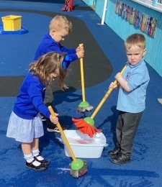
Bryntirion Infant School
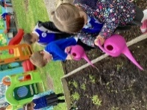

Curriculum Summary 2023-2024
Welcome to Our Curriculum!
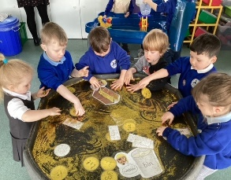
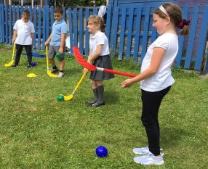


Bryntirion Infant School approach to learning.
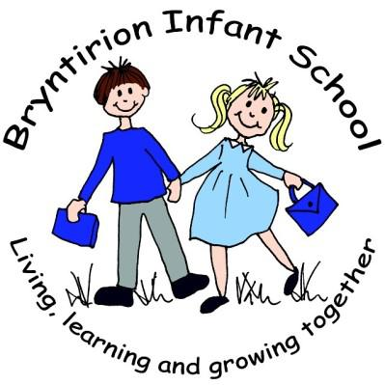


Our Aims
Developed in collaboration with parents, Governors, pupils and staff and based on the Four Purposes of the Curriculum for Wales, our Curriculum is unique to our school. They underpin everything that we do, including improvement targets, planning and the professional development of staff. We aim to meet the needs of our learners through creative and meaningful activities. Pupils experience a thematic approach to learning that helps them create connections and learn through memorable experiences equipping them for the future while reflecting on the unique identity of our school and community.

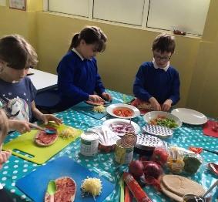

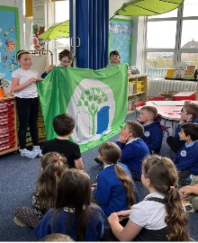

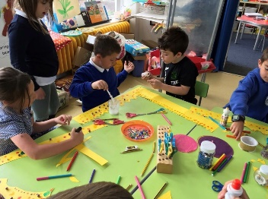
How our curriculum meets the required elements set out in the national framework, starting from the four purposes.

Vision Statement
Our statement ‘LIVING, LEARNING AND GROWING TOGETHER’ reflects our understanding and beliefs, as we aim to ensure, we are a community where all children feel loved, respected and encouraged to develop to their full potential.

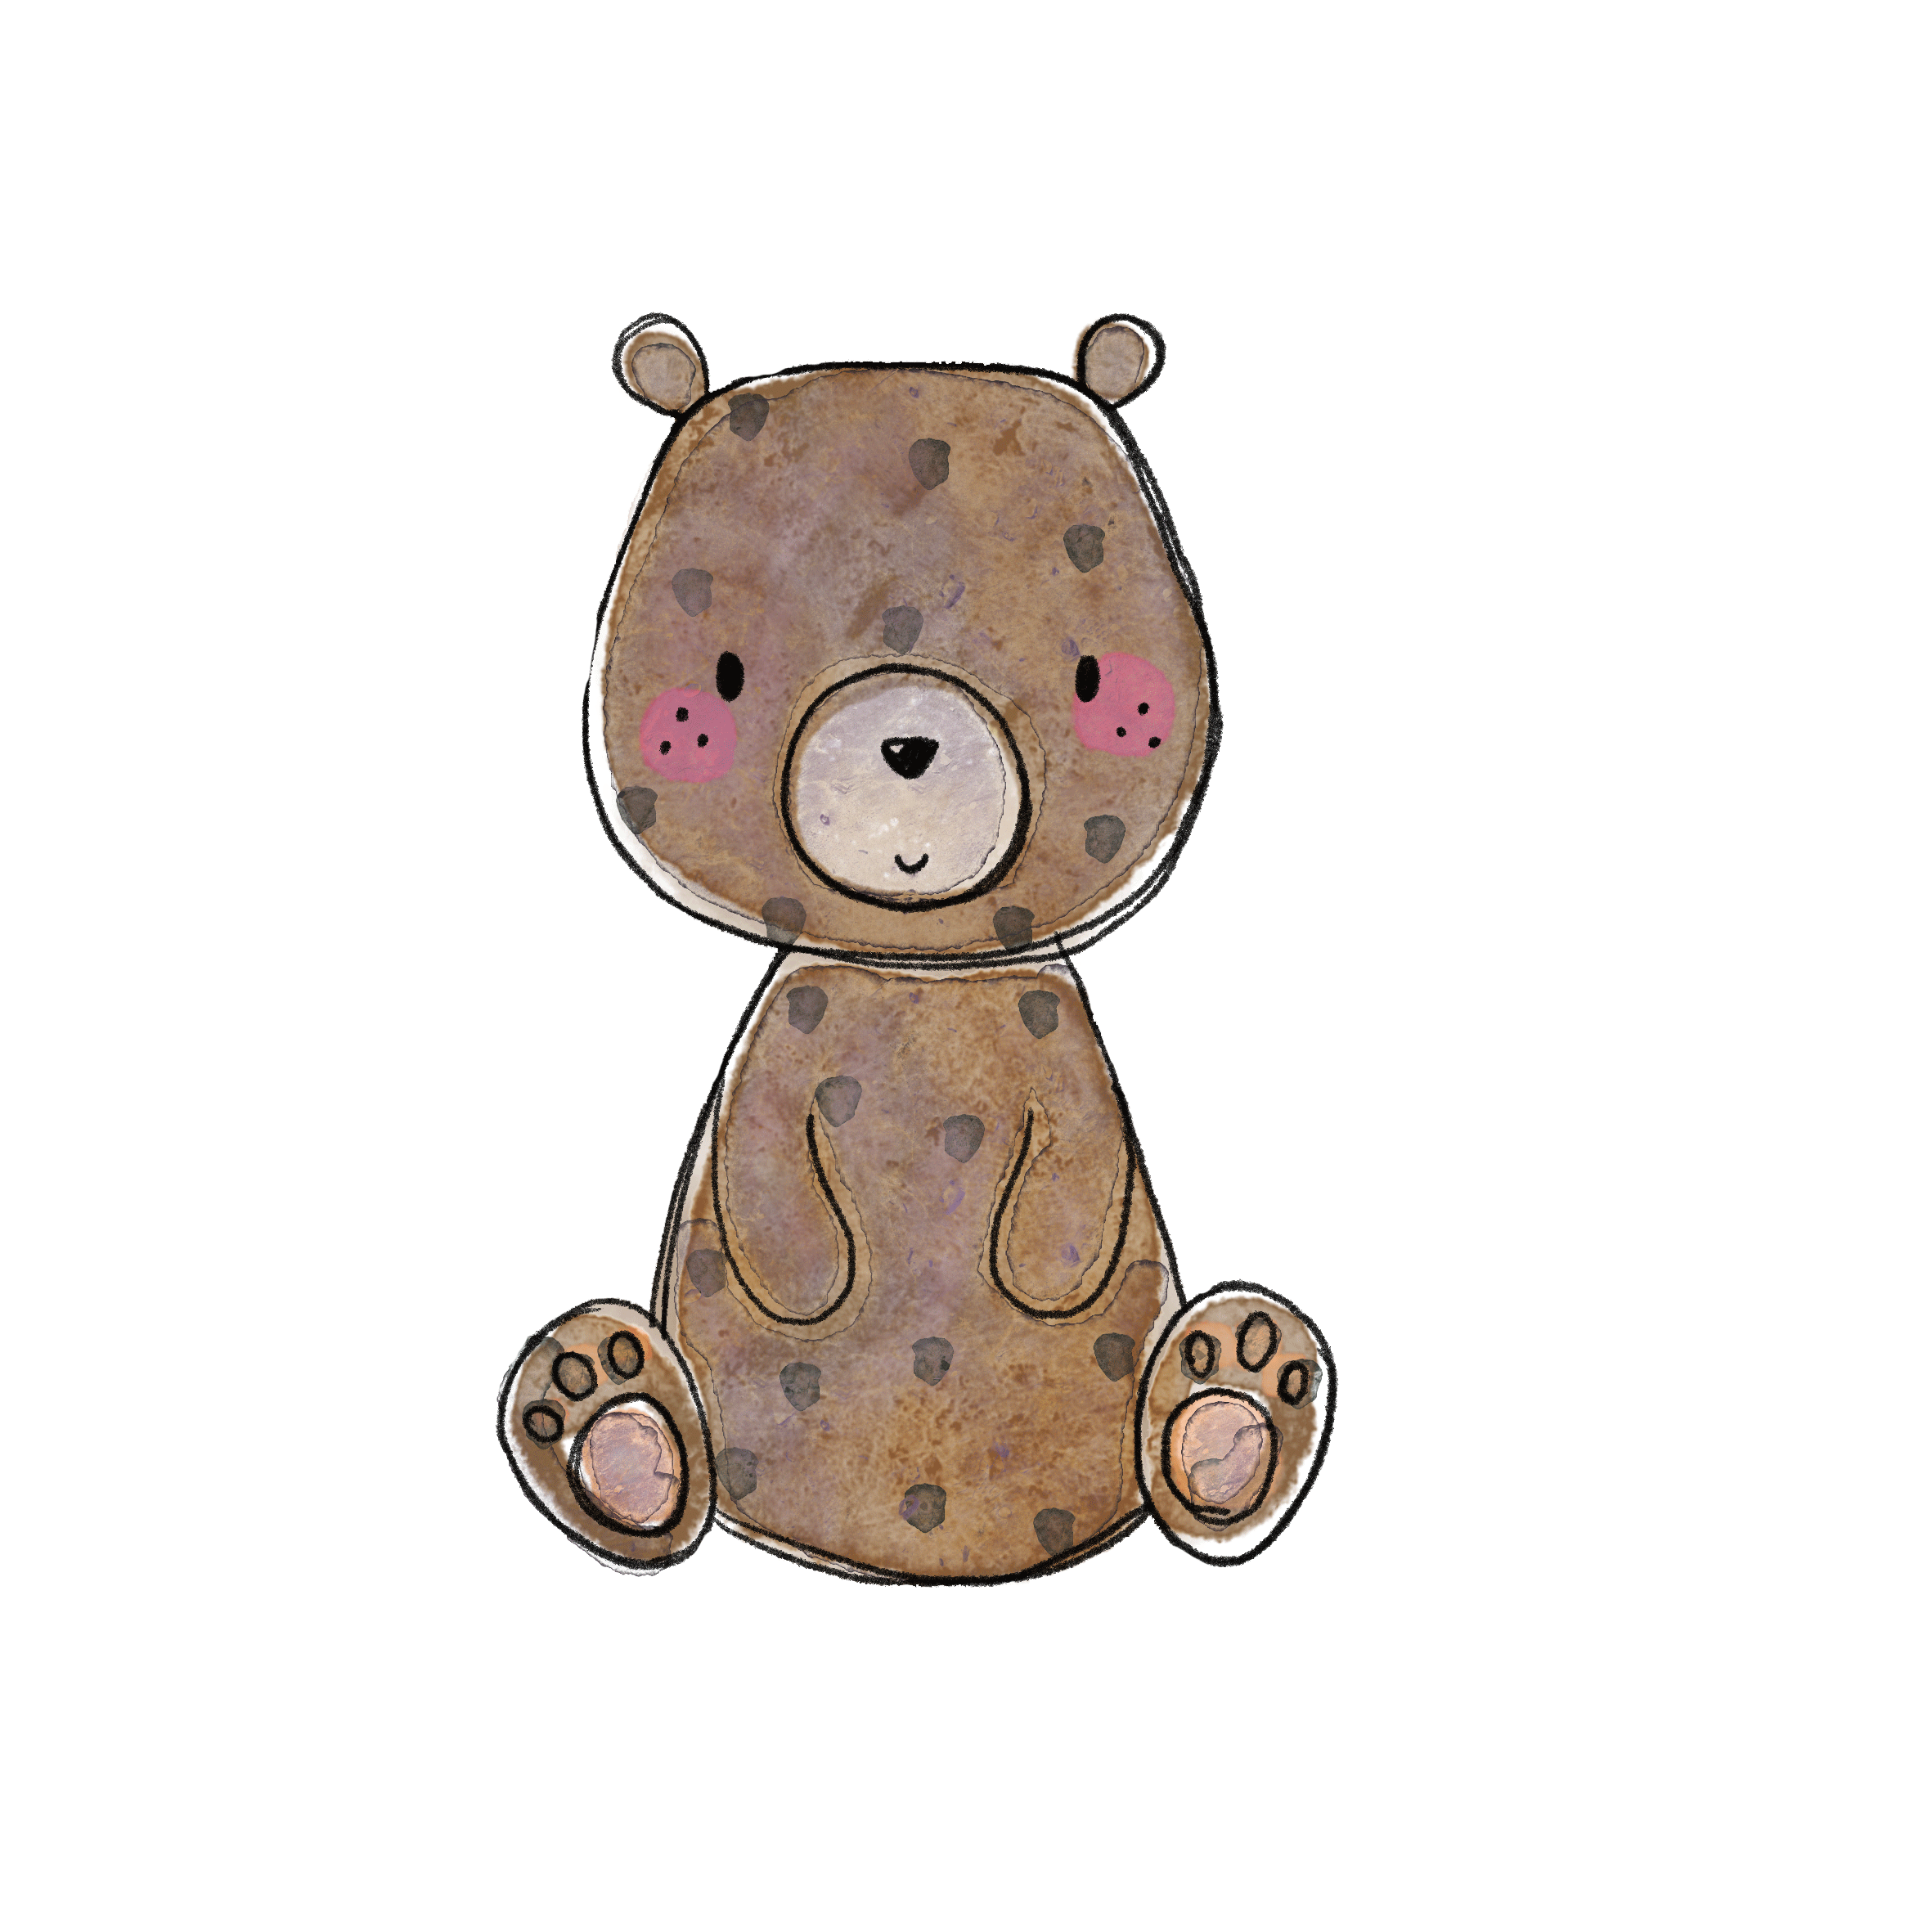
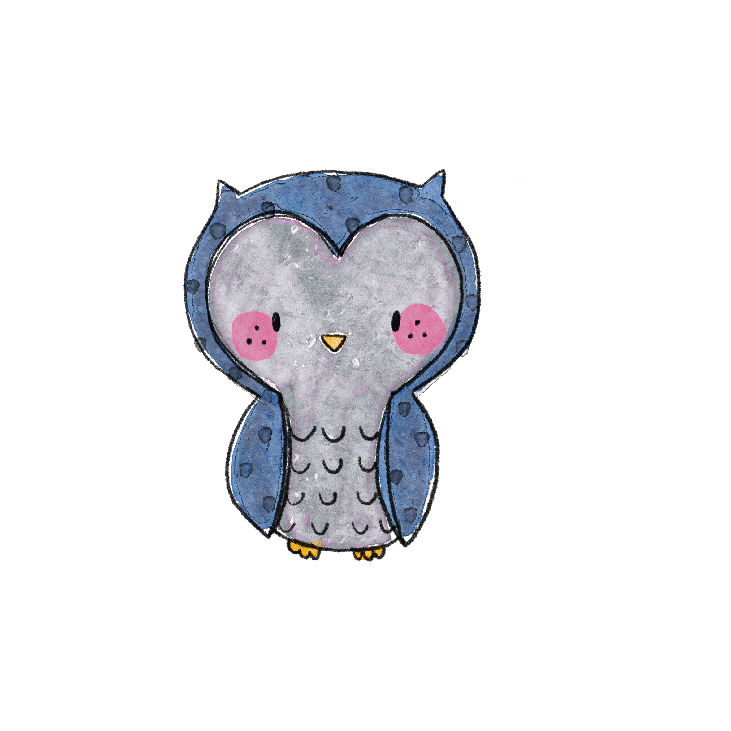

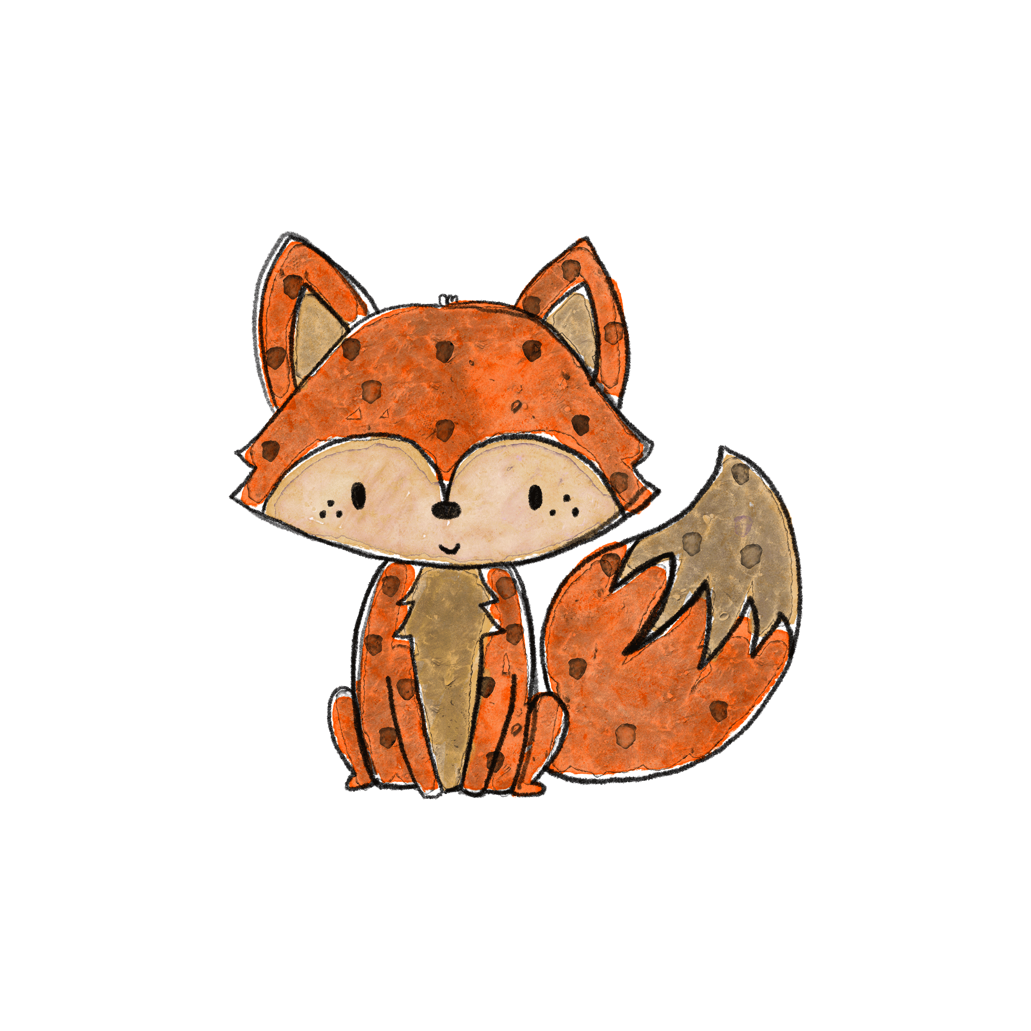
At Bryntirion Infant School, we have been working hard to prepare for the new Curriculum for Wales – planning, designing and refining an inspiring, enriching curriculum for our 21st Century learners. As a school, we have adopted a thematic, cross-curricular approach to teaching and learning that blends the six Areas of Learning and Experience (AOLEs) – Languages, Literature and Communication, Mathematics and Numeracy, Science and Technology, Humanities, Health and Well-being and the Expressive Arts. Our curriculum:
- covers the six Areas of Learning and Experience.
- encompasses the statements of ‘What Matters’.
- reflects the principles of progression set out in the progression code.
- includes the mandatory curriculum elements (Religion, Values and Ethics framework (RVE), Relationships and Sexuality Education (RSE), Welsh and English)
- encompasses the mandatory cross-curricular skills (Literacy, Numeracy and Digital Competency)
- develops integral skills within a wide range of teaching and learning – creativity and innovation, critical thinking and problem-solving, personal effectiveness, planning and organising.
- incorporates opportunities for learning and consideration of cross-cutting themes – Local, national and international contexts, Careers and work-related experiences, Human Rights Education and Diversity.

BIS pupils will actively engage in real life experiences to allow them to solve problems that are purposeful.
BIS pupils will have a sense of belonging and will build positive relationships through experiences built on happiness and laughter.
BIS pupils will be able to seek to challenge themselves and others, question the world around and lead their learning.
BIS pupils will be respectful and honest in their every day lives, making good choices about their behaviour and finding out about values and beliefs in communities.

Ethical
Informed citizens. Ready to be citizens of Wales and the world.

Enterprising
Creative contributors. Ready to playa full part in life and work.

Ambitious
Capable learners.
Ready to learn throughout their lives.

Healthy
Confident individuals. Ready to lead fulfilling lives as valued members of society.
How children learn is as important as what they learn. Our teachers teach through a range of
approaches, not restricted, but including those outlined in the 12 Pedagogical Principles.





BIS Curriculum is broad and balanced through topic content approaches to learning and teaching and it is always evolving.
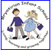
12 Pedagogical Principles

Focuses on 4 Purposes   | Challenges all Learners   |   Uses a blend of approaches including direct teaching | Involves problem solving, creative and critical thinking   |   Builds on previous knowledge and skills and engage interest   | Provides authentic context for learning  
Includes assessment for Learning   |   Ranges with and across areas of learning and experiences |   Reinforces cross curricular responsibilities |   Encourages children to take increasing responsibility for their own learning |   Supports Social and emotional development and positive relationships | Encouraged collaboration  

Areas of Learning and Experiences

Expressive Arts | 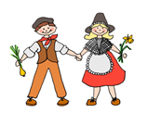  Health and Well-Being | Humanities | Languages, Literacy and communication | Mathematics and Numeracy | Science and Technology



Wider Skills

Planning and Organisation
Implementing solutions, executing ideas and monitoring and reflecting on results.
Critical Thinking and Problem Solving
Critical and logical processes to analyse and understand situations and develop responses.

Personal Effectiveness
Reflecting on and understanding oneself and others behaving in effective and appropriate ways: being an effective learner.
Creativity and Innovation
Generating ideas, openness and courage to explore ideas and express opinions.

Planning
Each half term, topics with a specific AOLE bias are chosen and a balance between the AOLEs is achieved throughout the academic year. We are running a two-year cycle of topics.

Literacy Numeracy and Digital Competencies Frameworks, RSE and RVE to be linked to thematic / cross-curricular topics where appropriate. Discrete lessons may be planned and taught at relevant times throughout the year.



What Our Curriculum Looks Like

Our curriculum is based on striving to make our pupils independent learners who are motivated and enthusiastic. It is important to us that the learning in our school is child centred and Pupil Voice is integral to our planning, teaching and learning. In class, focus tasks are taught in ‘bubbles’ with an adult supporting, guiding and challenging all. Learning outside the ‘bubbles’ takes place in our enhanced provision which children access independently. These ‘Busy’ activities provide authentic contexts for learning and build on previous knowledge and skills. We constantly encourage collaborative work involving problem solving and creative and critical thinking. The strategies we use encourage pupils to take responsibility for their own learning helping them become ambitious and capable learners. Theme days / weeks are used to inspire the pupils and give them a context for their learning.

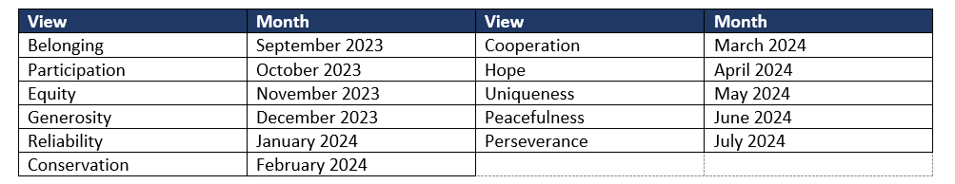

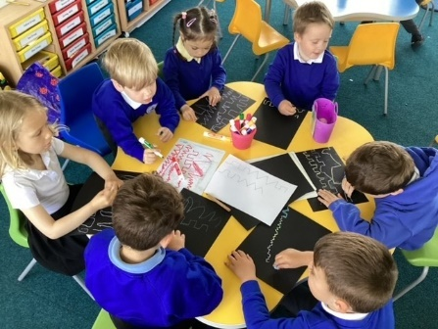



At Bryntirion Infant School we promote VIEWs (values, ethics, independence and wellbeing) to encourage and support the spiritual, moral, social and cultural well-being of every child. We hope that learning about the importance of these values in life will help shape our children, guide their behaviour and empower them to become effective learners and good citizens. We focus on one value every half term. These are reference points for assemblies, class planning and around the school.
We are a Rights Respecting the Child Bronze award School. We want our children to feel happy, safe, confident and ready to learn. Being a Rights Respecting School means we are building strong relationships between teachers and peers based on mutual respect and the value of everyone’s opinion. This is at the heart of BIS curriculum. Children are treated as equals by their fellow pupils and by the adults in the school. They have a moral framework based on equality and respect for all that will last a lifetime as they grow into engaged, responsible members of society.


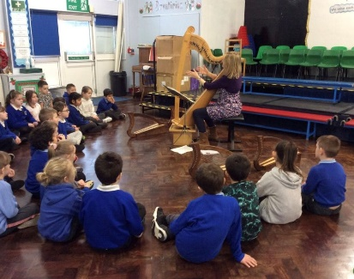

Assessment
Using topic maps, knowledge skills and expertise topics are mapped ensuring progression. Assessments and moderation are used to identify pupil progress and ensure high standards. Teachers regularly assess using evaluations, observations, teaching, marking and standardised assessments.


Reviews, feedback and ongoing revision of the curriculum
The world is continually changing and our curriculum reflects that. We work within school across the cluster and in partnership with Governors, Central South Consortium, Local Authority to develop a shared understanding of progression and to plan for transition for learners between schools. This understanding will then form the basis of our judgements on the effectiveness of our curriculum and will lead to suitable regular revisions of the curriculum.

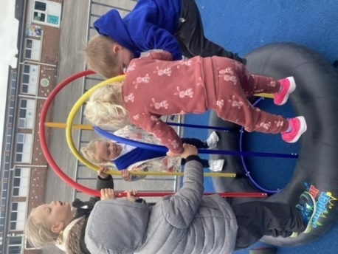


Academic Research
To ensure that BIS curriculum is based on current education theory, research is used to inform curriculum development. As part of School improvement, any curriculum changes are preceded by research, prototyping and evaluation.
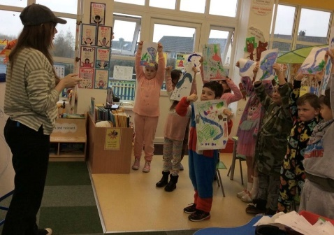
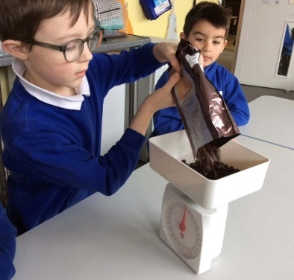
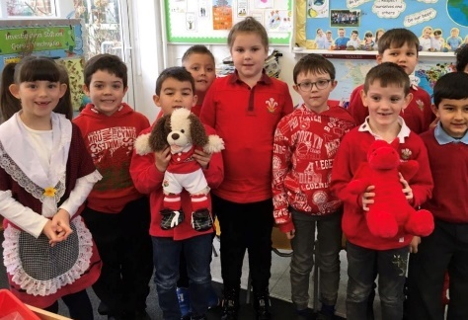

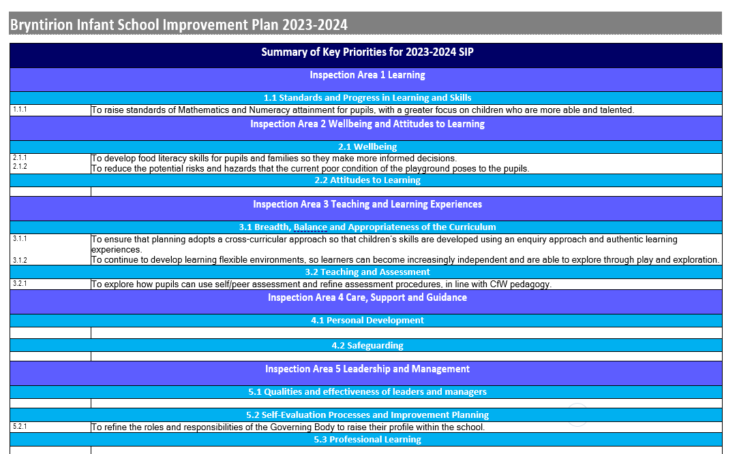
Bryntirion Infant School Improvement Budget for 2022-2023 is… £16,550 (including grants)

Priorities
OBJECTIVE 1 LEARNING Inspection Area 1 (1.1 Standards and progress in learning and skills)
Improvement focus: Priority 1 | 1.1 To raise standards of Mathematics and Numeracy attainment for pupils, with a greater focus on children who are more able and talented. |  |  |  |  |  |  |  |  |  |  |  |  | Link Governors: |  |  | Mark Davies and Sarah Phillpin
Rationale from self-evaluation: | Whilst most pupils (91%) across the school have shown good progress in the last term in the Mathematics and Numeracy Area of Learning and Experience, our tracking shows that there are too few children working above expected level.
Objective |  | Actions | Costs £ |  |  | Resource(s) |  | Lead Person(s) |  | Timescale |  | Success Criteria |  |  |  |  |  |  |  | RAYG
1.1.1 |  | 1.1.1a MN Developer to organize a Development Day with Big Maths with a focus on how the scheme can support MAT pupils. | £600 |  |  | Non-contact time |  | LH |  | Autumn 2023 |  | The AoLE Developer know how the scheme can be used to support MAT pupils and applies this knowledge to support practitioners in school. MN Developer to upskill staff through training session/s.
 |  | 1.1.1b MN Developer to visit other Big Maths schools where data for MAT is rich and speak to CSC Link Advisor to support. | £150 |  |  | Non-contact time |  | LH |  | Autumn 2023 |  | Effective practice is put into practice in school and monitored. MN Developer to upskill staff through training session/s.
 |  | 1.1.1c MN Developer to organize the children into homogenous groups. These will be re-evaluated half termly and pupils moved into appropriate group. | £300 |  |  | Non-contact time |  | LH |  | Spring 2024 |  | MN Developer analyses pupil data and places pupils in groups with like-minded pupils. Skills and knowledge are easier to pitch to ensure pupils learning is stretched and staff have high expectations. The numbers of pupils that are MAT have increased.
OBJECTIVE 2 WELLBEING AND ATTITUDES TO LEARNING Inspection Area 2 (2.1 Wellbeing; 2.2 Attitudes to Learning)
Improvement focus:  Priority 2 | 2.1 To develop food literacy skills for pupils and families so they make more informed decisions.  2.2 To reduce the potential risks and hazards that the current poor condition of the playground poses to the pupils. |  |  |  |  |  |  |  |  |  |  |  |  |  | Link Governors: |  |  |  | Jeff Lewis and Louise Bullock
Rationale from self-evaluation: | Big Bocs Bwyd opened 30.6.23. It quickly became apparent that BBB users’ food awareness was poor. Allotment food was left and they lacked the generational knowledge and skills to cook from scratch. Processed and less nutritious food were most popular. During our April 2023 Estyn inspection, inspectors issued a Wellbeing letter about the poor condition of the yard, and that is posed risk to young pupils (R1- Address the well-being issue identified by the team during the inspection relating to the state of repair of the school playground).
Objective |  | Actions |  | Costs £ | Resource(s) |  | Lead Person(s) |  | Timescale |  |  |  | Success Criteria |  |  |  |  |  |  | RAYG
2.1.1 |  | 2.1.1.a To develop children’s food literacy skills with regular cooking experiences with seasonal produce. |  | £500 | Cooking supplied and equipment |  | LB/BB |  | Autumn 2023 |  |  |  | Regular opportunities to buy, prepare and make food produce will improve pupils’ knowledge and skills at making home-made produce. Children make food to ‘sell’ in the BBB. Experiences are purposeful, seasonal and authentic and support the CfW.
 |  | 2.1.1b To purchase necessary resources and equipment for effective running of the Food Forest. |  | £5000 BBB LA grant | Polytunnel, shed, tools, compost, seeds, raised beds etc. |  | LB/JE |  | Autumn 2023 |  |  |  | Equipment is readily available to run the project. Pupils are involved in the purchases.
 |  | 2.1.1c To develop a Food Forrest on school grounds so children grow, care for and harvest home-grown food. Pupils understand how to be self-sufficient. |  | £100 refreshments  £600 skips | Spades/shovels, skips |  | LB/JE |  | Autumn 2023 |  |  |  | A designated area is cleared and a landscaping plan in place to foster best crop yields. Volunteer event (pupils, families and staff) will enable grounds to be cleared for execution of the Food Forest Plan. Children become aware of gardening terminology.
 |  | 2.1.1d Food Forest Leader/s (FFLs) organize and run sessions for parents to work with their child on the Food Forest. |  | £0 | Timetables with FF slots each week |  | LB/JE |  | Spring 2024 |  |  |  | Children work in partnership with parents to help develop the class raised beds. Pupils’ begin to understand the importance of growing food and how at home they could grow. #informationispower
 |  | 2.1.1e For BIS FFLs to develop opportunities for Bryntirion Comprehensive School pupils (Eco / Welsh Bacc.), Bridgend College Landscape students and Laleston Allotment group adults to support developing knowledge and skills of growing food. |  | £0 | None |  | KP, LB, JE |  | Autumn 2023 |  |  |  | Expertise from the community empowers participants and will ensure the success of the Food Forest. For pupils to know that it is good to learn from others that know more. There is regular and appropriate, timely participation of community partners to support the project.
 |  | 2.1.1f For school based Community Champions to lead on regular Intergenerational Cooking sessions to support families knowledge and skills. |  | £1600 Asda Grant | Hall time, mobile cooking trolleys with cookers and tools, raw ingredients |  | LB |  | Spring 2024 |  |  |  | Children (with support from family adults) are developing their food literacy knowledge and skills and know how to make a range of produce, using seasonal grown produce and bought. Families develop nutritional awareness.
2.2.1 |  | 2.2.1a To review current accident/incident report procedures for the main tarmac playground. |  | £0 | Current paperwork |  | KP, LB |  | Autumn 2023 |  |  |  | The number of serious accidents is easier to identify. There is clear guidance for staff on levels of reporting e.g. slip home, online log, H&S risk assessment.
 |  | 2.2.1b To review the yards safety with Health and Safety Officers and look at how the LA can make the yard safer for pupils. |  | £0 | LA Report |  | KP |  | Autumn 2023 |  |  |  | There is a plan in place to renew the yard so it is safer for learners to play.
OBJECTIVE 3 TEACHING AND LEARNING EXPEREINCES Inspection Area 3 (3.1 The breadth, balance and appropriateness of the curriculum; 3.2 Teaching and assessment)
Improvement focus:  Priority 3 | 3.1.1 To ensure that planning adopts a cross-curricular approach so that children’s skills are developed using an enquiry approach and authentic learning experiences.  3.1.2 To continue to develop learning flexible environments, so learners can become increasingly independent and are able to explore through play and exploration.  3.2 To explore how pupils can use self/peer assessment and refine assessment procedures, in line with CfW pedagogy. |  |  |  |  |  |  |  |  |  |  |  |  |  | Link Governors: |  |  | All
Rationale from self-evaluation: | Our April 2023 Estyn inspection recommendations were…R4- Develop the school’s curriculum to ensure coherence across all areas of learning and experience and R3 Improve the learning environment for younger pupils to ensure that there are greater opportunities for them to develop their skills through play and exploration and R2- Ensure that activities develop pupils’ independent skills successfully). We have also identified that whilst our current assessment arrangements provide a clear baseline and shows progress but is not relevant for all pupils, particularly Nursery pupils and those in our observation classes.
Objective |  | Actions | Costs £ |  | Resources) |  | Lead Person(s) |  | Timescale |  |  |  | Success Criteria |  |  |  |  |  |  | RAYG
3.1.1 |  | 3.1.1a To review current planning model and make necessary changes that ensure it allows teachers to plan cross-curricular learning opportunities. | £300 |  | Non-contact time |  | LH, RW |  | Autumn 2023 |  |  |  | Teachers planning allows staff to plan in a cross-curricular way. The new pro-forma reduces the burden on teachers. Strong links are made between AoLE.
 |  | 3.1.1b Teaching and Learning is fluid. No set timescales or topics. Learning is stage appropriate for the pupils being taught. | £0 |  | PPA, Staff meetings |  | LH |  | Autumn 2023 |  |  |  | The curriculum is appropriate to the stage of development of its pupils. Staff are not constrained by a theme lasting ‘x’ weeks or regurgitating learning from previous years. Pupils’ desires are followed and learning is relevant for pupils to develop independent thinking skills.
 |  | 3.1.1c To develop Mantle of the Expert pedagogy where learning is deeply rooted in authentic, purposeful learning opportunities that are enquiry based. | £2000 |  | INSET training events  Coaching Days |  | LH |  | Spring and Summer 2024 |  |  |  | Teaching and Learning is relevant and authentic. Learning takes a ‘team’ approach and is led by a commission with the goal of answering a big question. There are high levels of pupil engagement and is steered by pupils. Staff move in and out of role to drive learning and support the development of knowledge and skills.
3.1.2 |  | 3.1.2a For staff to continue to develop learning environments that foster pupils’ independence both inside and outside. | £5000 |  | Purchase of resources |  | RW |  | Autumn 2023 |  |  |  | Indoor and outdoor learning environments are suitable for the stage and age of pupils using it. Carefully consideration has been made to ensure that pupils are offered a range of resources and equipment to consolidate learning and drive learning.
 |  | 3.1.2b To understand the importance of play and exploration has for child development and the role adults play during continuous provision. | £600 |  | Twilight training |  | RW |  | Autumn 2023 |  |  |  | Staff understand why play is crucial, particularly for the youngest pupils. They have the knowledge and skills to scaffold learning and allow independence to be fostered. Play based learning provides staff with opportunities to see what a child can do and what learning is important for their next steps.
 |  | 3.1.2c To utilize electronic observational assessments to drive the planning- focused Seesaw observations. | £? ICT training to use Seesaw functions |  | Twilight training |  | RW |  | Summer 2023 |  |  |  | Regular observational assessments recorded and annotated digitally provides a trail of formative assessments which are used to plan the next steps for pupils’ learning.
3.1.3 |  | 3.1.3a To introduce regular self and peer assessment opportunities within classroom practice. | £0 |  | None |  | All staff |  | Summer 2023 |  |  |  | Children have the opportunity to evaluate their own and others learning. There is consistency of approach across the school.
 |  | 3.1.3b To further develop our tracker so it is relevant for all pupils- focus on the lower end of the assessment profile (Nursery and Observation classes) | £400 |  | Non-contact time |  | GE, LR and MT |  | Autumn 2023 |  |  |  | The tracker of pupil data is effective for all pupils and shows progress clearly.
OBJECTIVE 4 CARE, SUPPORT AND GUIDANCE Inspection Area 4 (4.1 Personal development; 4.2 Safeguarding)
Improvement focus from  self-evaluation: | There are no actions for this Inspection Area this year.
OBJECTIVE 5 LEADERSHIP AND MANAGEMENT Inspection Area 5 (5.1 Quality and effectiveness of leaders and managers; 5.2 Self-evaluation processes and improvement planning; 5.3 Professional learning)
Improvement focus:  Priority 4 | 5.2 To refine the roles and responsibilities of the Governing Body to raise their profile within the school. |  |  |  |  |  |  |  |  |  |  |  |  |  |  | Link Governors: |  |  | Jeff Lewis and Beth Hopkins lead, but all
Rationale from self-evaluation: | Governors are effective in carrying out their core duties but have not been a visible part of the school since Covid-19.
Objective |  | Actions |  | Costs £ | Resources) |  | Lead Person(s) |  | Timescale |  | Success Criteria |  |  |  |  |  |  |  |  | RAYG
5.2.1 |  | 5.2.1a For CoG and VCoG to work with the HT on the CSC Governor Self-Evaluation Toolkit to formulate short, medium and long-term actions. |  | £0 | CSC Toolkit |  | KP, JL, BH |  | Spring 2024 |  | Senior governors are aware of the strengths of the Governing Body and prioritise actions to improve governance. Information highlighted is shared with governors during Governing Body meetings.
 |  | 5.2.1b For Governors to visit the school (timetabled linked to MER focus AoLE) to work with staff to develop their understanding of their link AoLE and provide challenge and support. |  | £0 | None |  | All AoLE Developers  HT |  | Summer 2024 |  | Governors have a clear understanding about their AoLE: strengths and areas of development. To speak to the HT about their experiences. To feedback to all governors during Governing Body meetings.

