
PRIVACY NOTICE FOR PUPILS
What is personal data?

Personal data is information about you. This is information that could potentially identify you. This includes your name, your date of birth, your address and phone number.
What personal data does the school collect?
Your information, including your name, address and date of birth;
Your school grades and records;
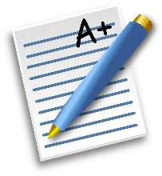
Safeguarding information;
Medical information;
Attendance records;
Photographs and CCTV;
Information about your homelife.
Why does the school need this information?
We have a duty of care under the law to you. The law states that we need this information to know who is attending the school and to provide you with an education.

It is important for the school to keep you safe and hold this information to enable us to do this.
Who does the school share this data with?
It is important for us to share some of this information with the police, the NHS and exam boards.
We must also share this information with the local authority.
We share information with other schools and colleges you may wish to attend.
Where does the school keep this data?

We keep this data within the school, in a large manner of ways. This could be in files under lock and key or on a computer with strong security.
How long does the school keep this data for?
We often review our files to ensure we are only holding the documents we need. Once you leave the school, we may be required to keep some information about you.
Any questions, please contact Mrs Lisa Hearn or the School’s data protection officer, Judicium Education at dataservices@judicium.com.

