
Bronze Award/ Gwobr Efydd
Action Plan/Cynllun Gweithredu Cymraeg Campus Siarter Iaith
Ysgol Babanod Bryntirion  (Medi 2019 -Gorffennaf 2021 )
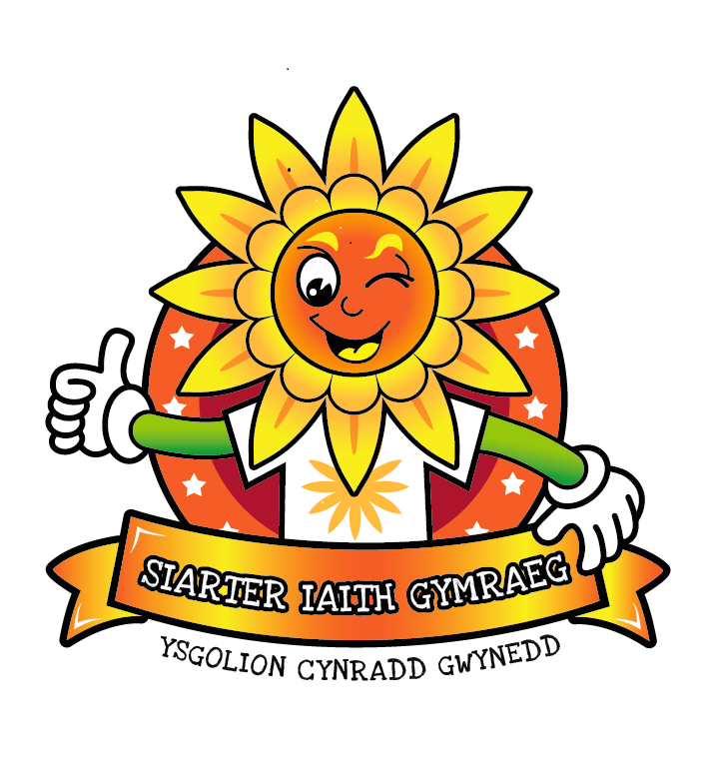


Outcomes/Deilliannau | Actions  Camau Gweithredu | Who?  Pwy? | By?  Erbyn? | Evidence?  Tystiolaeth
Pupils/Disgyblion
All pupils are aware of the Cymraeg Campus(CC) bronze targets | Assembly to launch CC to whole school  Introduce Seren a Sbarc in a whole school assembly  Small groups of Year 2 to complete baseline questionnaire | LH & GE  LH & GE  GE | To be completed at start and end of year in which is school is ready for verification | Pupil voice  Questionnaire  Website  Photos and announcements on twitter school website, newsletter to parents  Questionnaire results  Displays  Criw Cymraeg minutes
Criw Cymraeg to be established and at least 1 targets per term are agreed and actioned by the Criw | Criw Cymraeg to discuss targets and ideas (pupil voice to be established)  Criw Cymraeg to keep minutes of targets and record way forward | GE and Criw Cymraeg  GE and Criw Cymraeg |  | Criw Cymraeg minutes  Competition entries  Photo evidence
Parents/Rhieni
The parents are informed and aware of Cymraeg Campus’ targets | App notification  School’s Twitter  School’s newsletter or website | GE  GE  GE |  | Twitter  Facebook  Website
The advantages of bilingualism are discussed with parents | SEESAW evidence posted by staff and pupil to their online accounts. Posters shared and displayed around the school on Twitter, Facebook, Website  Pamphlet for parents with examples of bilingualism (Example on Cronfa)  Communal display for all to see celebrating the advantages and benefits of speaking Welsh  Shared on our Website, Twitter, Facebook page | All staff  GE  All staff  GE |  | SEESAW Posters  Pamphlet on  Cronfa  Website  Twitter  Facebook  Display  Twitter  Facebook  Website
School could encourage parents to learn basic Welsh | WAP Welsh and Play for parents in school  Pori Drwy bilingual coffee mornings  Reading cafes  Bilingual home tasks  Phrase of the week is shared to encourage parents to use at home | GE & GM  CM & AC  BB GE LH  All Staff  All staff |  | Twitter  Facebook  Learning Logs  Posters  School website
Governors/Llywodraethwyr
The governors are informed and aware of Cymraeg Campus’ targets | Criw Cymraeg to present Cymraeg Campus’ targets to the governing body  Welsh link Governor to be kept updated on school target progress.  School and/or the Criw Cymraeg to present termly progress reports to the governing body |  |  | Governing body minutes  Power Point Presentation  Emails  Visits
School Staff/Staff yr Ysgol
To engage all stakeholders with the Cymraeg Campus initiative | Cymraeg Campus presentation to whole staff  Cymraeg Campus to be a high priority on the school SIP  Cymraeg Campus targets and progress to be regularly monitored and discussed in staff meetings  A communal school display clearly showing all targets and their progress to be visible in a focal area of school | GE  All Staff  GE  GE |  | Cymraeg Campus presentation on Cronfa  Staff meeting minutes  SIP  Class work and displays, eg cross-curricular work, a bilingual learning environment  Display
All stakeholders have a clear vision to developing bilingualism across all aspects of school life | All staff have equal responsibility in developing a bilingual environment within the classroom and outside of the classroom  Reward system to be implemented by staff and pupils, eg  Seren yr wythnos  Tocyn iaith,  Siaradwyr Cymraeg  House Points/Pwyntiau Llys  Training of canteen and mid-day supervisors | All staff  All staff  GE Sian Walters |  | Action Plan/Planning  Learning walks  Twitter, eg brawddeg yr wythnos  Language prompts around the kitchen hatch
Recording of Cymraeg Campus progress | Whole school are part of the monitoring process of each target.  The target is lit when 60% of each target has been achieved as part of the Welsh assembly (Taniwch y ddraig) | All staff and pupils |  | Cymraeg Campus display
Training/Hyfforddi
Staff are made aware of training to support Cymraeg Campus targets | For example:  Criw Cymraeg  Mid-day supervisors and canteen staff  LSO training  Group work incidental welsh  Teachers- model lesson example  Administrative staff  Yard game etc | SL  Teachers  WEO Sian Walters |  | Pupil voice  Learning walk  Twilights  Training afternoons
Gweithgareddau Cyfoethogi/Enrichment Activities
Staff are aware of the need to promote a positive attitude towards Welsh culture and ethos | For example:  School Eisteddfod  Celebration of Welsh cultural days  Welsh Fortnight  Folk dancing  Traditional cooking  External agencies to include sports, storytellers, theatre groups  Trips | SLT  GE  All staff |  | Twitter  Newsletter  Photographic and video evidence  Visitors

