TARGEDAU Y WOBR EFYDD



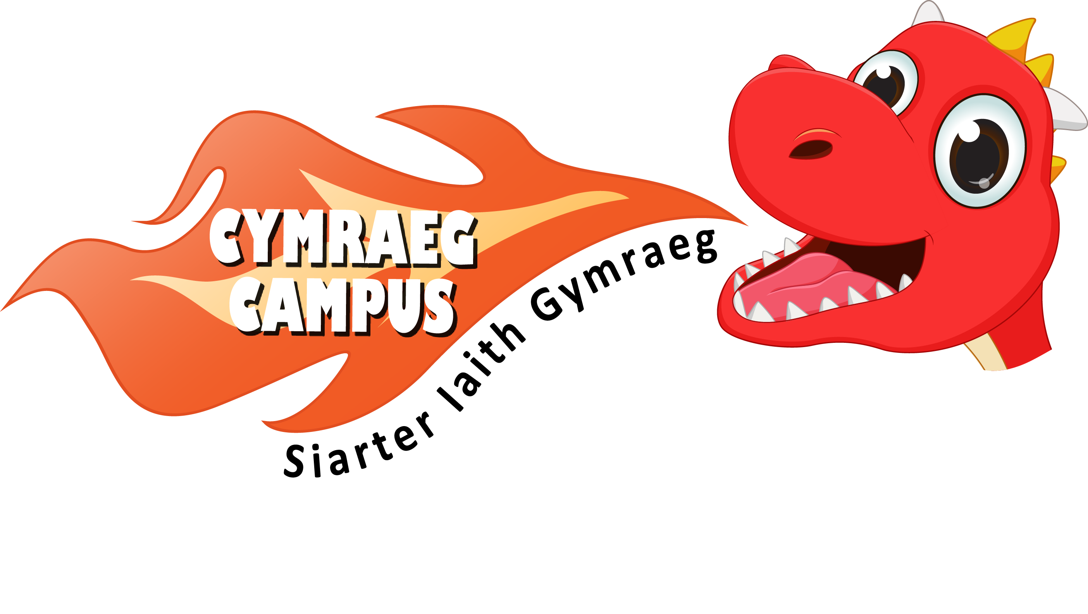
BRONZE AWARD TARGETS
GWOBR EFYDD: Targed 1
Establishing a visual Welsh Ethos

A general Welsh display A Welsh display outside
in classroom. one of the classrooms.

The reception area reflects An element of Welsh at an
a contemporary vision of appropriate level is visible
Wales. on other classroom subject
displays.

Welsh is prominently displayed Criw Cymraeg contribute
around the classroom e.g. to the school’s newsletter
* welcome poster on the door reporting on the school’s
* the majority of areas are named progress on the language
in Welsh charter.
* the majority of materials are
labelled in Welsh

Welsh is prominent on the
school’s website e.g.
The majority of areas inside and * Welsh signage on school
outside of the school have Welsh website
/bilingual signage. * Links to online activities
for parents and children

School holds a competition to
design a ‘Croeso’ poster which
will be displayed around the
school.

School’s progress in Language
Charter’s Bronze Award is
clearly displayed.

GWOBR EFYDD: Targed 2
The advantages of learning Welsh

Pupils read ‘Ein Cymru Ni’ Each class has a take home
factual books which focuses Welsh initiative mascot. A
on the concept of ‘Welshness’. short session is dedicated to
questioning the mascot on his
return.
Pupils to create a display in a
communal area within the school
that promotes the advantages of Parents are invited to be part
learning Welsh. of Welsh enrichment activities.

Pupils create posters to Staff attend all designated
encourage other people to speak Welsh courses run by the
Welsh e.g. Local Authority.
‘Siaradwch Gymraeg gyda
ffrindiau’
‘Mae Cymraeg yn cwl’ The school establishes a link
with a local school so that
pupils can converse in Welsh
Pupils are taught the benefits via email or video link on
of learning Welsh. familiar topic.
e.g. news

Pupils have learnt the Welsh
national anthem ‘Mae Hen
Wlad fy Nhadau’.

Cwricwlwm Cymraeg is
planned for.

GWOBR EFYDD: Targed 3
The use of incidental Welsh in the classroom

Teaching staff use incidental Support staff use incidental
Welsh to give basic commands Welsh to give basic commands
throughout the day. throughout the day.

Support staff use basic
Pupils use Welsh incidentally commands in Welsh when
when expressing basic needs working with groups of
e.g. children.
Ga i fynd i’r ty bach os gwelwch
yn dda?
Teachers greet each other in
Welsh.

Each class has established the Pupils understand and
‘Helpur Heddiw’ initiative. respond to basic Welsh
questions and commands.

The register and dinner order
is taken in Welsh.

Teachers write a general marking
comment in Welsh in pupils’
workbooks in most subjects.

The date is written in Welsh on
the whiteboard and in pupils’
workbooks in most subjects.

GWOBR EFYDD: Targed 4
The use of incidental Welsh outside of the classroom

Pupils use Welsh incidentally The school holds a Welsh
when expressing basic needs afternoon e.g. ‘Welsh rugby’
in the dinner hall e.g. Ga i for developing the pupils’
ginio rhost os gwelwch yn dda? language skills across a
range of practical activities
e.g. ICT, craft, games etc…
Criw Cymraeg have an interactive
display in a communal area
to promote the phrase of the week. Duty staff model Welsh yard
games.

Criw Cymraeg to work on one
project to promote use of Pupils understand and respond
Welsh outside of the classroom to Welsh questions and
e.g. Fruit shop is run in Welsh commands when outside of
Prepare a ‘bocs Cymraeg’ the classroom.
for wet break / breakfast club
Prepare language posters for
the dinner hall.

Teaching staff and support
staff use incidental Welsh to
give basic commands outside
of the classroom.

Phone calls are answered in
Welsh and answerphone message
is bilingual.

Pupils greet staff in Welsh.

GWOBR EFYDD: Targed 5
Welsh in assemblies

Criw Cymraeg are responsible for Criw Cymraeg introduce the
leading a part of the weekly Welsh phrase of the week in the
assembly. weekly Welsh assembly.

A weekly Welsh assembly is held Criw Cymraeg hand out rewards
which all staff attend. in the weekly Welsh assembly.

Headteacher and teaching staff use
Welsh to greet during every
assembly.

A simple Welsh prayer is said in
Welsh in the weekly Welsh
assembly.

Welsh songs and hymns are sung
in the weekly Welsh assembly.

Criw Cymraeg greet pupils and staff
as they enter the Weekly Welsh
assembly.

GWOBR EFYDD: Targed 6
Apps and websites to enhance learning and enjoyment

Pupils make good use of the ‘Ap Geiriaduron’ is installed on
discussion feature on the HWB school iPads and pupils can
platform to answer simple questions confidently use it to check
in Welsh. spelling and meaning.

Some main oracy activities Pupils use iPads / cameras to
completed by pupils are showcased record oracy activities.
in pupils workbooks using QR codes.

Pupils to prepare posters to be
Teachers use Welsh iBooks on an displayed around the school
iPad connected to a whiteboard to that promote Welsh apps.
enhance learning.

Pupils have access to and make
good use of Welsh apps e.g. Alun
yr Arth, Hapus, Campau Cosmig.

Pupils use word processing
programs to complete written
tasks during their Welsh lessons.

A list of suitable Welsh websites is
readily available in each class.

GWOBR EFYDD: Targed 7
Enrichment activities

The school annually takes part in The Criw Cymraeg organise
the Urdd Eisteddfod stage and / or events to celebrate Dydd Gwyl
literary competitions for Welsh Dewi, Diwrnod Shwmae etc…
learners.

The school organises Welsh trips There is an emphasis on Welsh
e.g. to Llangrannog, Caerdydd when creating and selling
Glanllyn, Sain Ffagan etc… to products for enterprise activities
develop pupils use and enjoyment e.g. bilingual Welsh Christmas
of Welsh. cards, decorated cakes.

The school annually takes in Urdd The school runs a lunchtime or
sport activities. after school Welsh club with a
variety of activities.

The school occasionally invites
Welsh speakers into school.

The school organises an annual
Welsh Eisteddfod where all singing,
recitation and homework
competitions are through the medium
of Welsh.

Some KS2 pupils are members of the
Urdd.

GWOBR EFYDD: Targed 8
Developing reading

Teachers and classroom assistants Pupils have regular guided
have been given training on reading sessions and are
language needed to facilitate group encouraged to discuss content.
reading using e.g. Cynllun Colegau Record of these sessions are
Cymru Language Mat. kept.

The majority of pupils have a secure Pupils undertake a range of
grasp of the Welsh alphabet. activities to improve reading
fluency and teachers encourage
pupils to make good use of
Teachers use Welsh iBooks on an reading success criteria cards to
iPad connected to a whiteboard peer and self assess.
to enhance learning.

KS2 pupils read simple stories
Reading material at the appropriate to pupils in the Foundation
level is available in each classroom. Phase.

The school is beginning to create a Pupils are able to answer simple
rich Welsh reading environment questions about books and
e.g. phrases to discuss books are express their opinion simply.
displayed.

The school has recently undertaken
an audit of current resources and
has invested in a good range of
current suitable reading books and
magazines.

GWOBR EFYDD: Targed 9
Welsh across the curriculum

KS2 teachers make use of factual Pupils evaluate their work at
books e.g. ‘Ein Cymru Ni’, ‘A an appropriate level in Welsh
wyddoch chi?’, ‘Patagonia’, subjects e.g. Art, Design and
‘Botswana’ etc… Technology, Music etc… by
using simple patterns e.g.
Dw i’n hoffi / Dw i ddim yn hoffi
KS2 teachers sometimes use
cross-curricular books e.g. Pod
Antur books and DVD clips as a There is evidence of Welsh
tool for learning aspects of their cross-curricular work undertaken
topic work in Welsh. in pupils topic and subject
workbooks.

Teachers use Welsh across the
curriculum key ring cards, posters Pupils have a good grasp of
and language mats to aid pupils to subject terminology in Welsh in
use Welsh across the curriculum. a few subjects across the
curriculum.

Bilingual opportunities are included
in the majority of lesson plans. Aspects of one subject e.g. P.E.
or Art is taught through the
medium of Welsh in all classes.
An element of Welsh at appropriate
level is visible on other classroom
subject displays.

GWOBR EFYDD: Targed 10
A positive attitude

Pupils play a variety of games Pupils are provided with a range
through the medium of Welsh of audio / audio visual Welsh
e.g. stimuli and are able to participate
* classroom language games in a range of exciting activities
* yard games through the medium of Welsh e.g.
* warm up games during P.E. * Welsh DVDs
lessons * Welsh TV programmes
* Jamboree

The school has a termly evolving
graffiti wall where pupils respond Pupils are given the opportunity
in Welsh to a question asked by to use Welsh in a range of real life
teachers of the Criw Cymraeg. situations e.g.
* buying items
* ordering food
The Criw Cymraeg distribute
rewards in the weekly Welsh
assembly e.g. Questionnaire shows that the
* siaradwr y wythnos majority of pupils enjoy learning
* dosbarth y wythnos Welsh.

The school uses a variety of
ways to reward children and
staff for speaking Welsh e.g.
* win a place on the Welsh
dinner table in the dinner hall
* tocyn iaith
* team points
* certificates

The school has set up a Criw
Cymraeg which leads on
developing Welsh in the school.

Welsh stickers or stamps are
used to reward good work.

