Dear Parents, Staff and Governors

Dyma’r Criw Cymraeg! We are this years ‘Criw Cymraeg’! We are here to help everybody know about how we are all working hard to learn Welsh. We have special badges that we wear everyday so people know that we are part of the ‘Criw’.

We are working towards achieving the Cymraeg Campus Siarter Iaith Gwobr Efyd. (Bronze Award). To do this we need you to help and support us in learning, sharing, speaking and promoting being welsh and the welsh language. There are 10 targets for us to try and achieve.
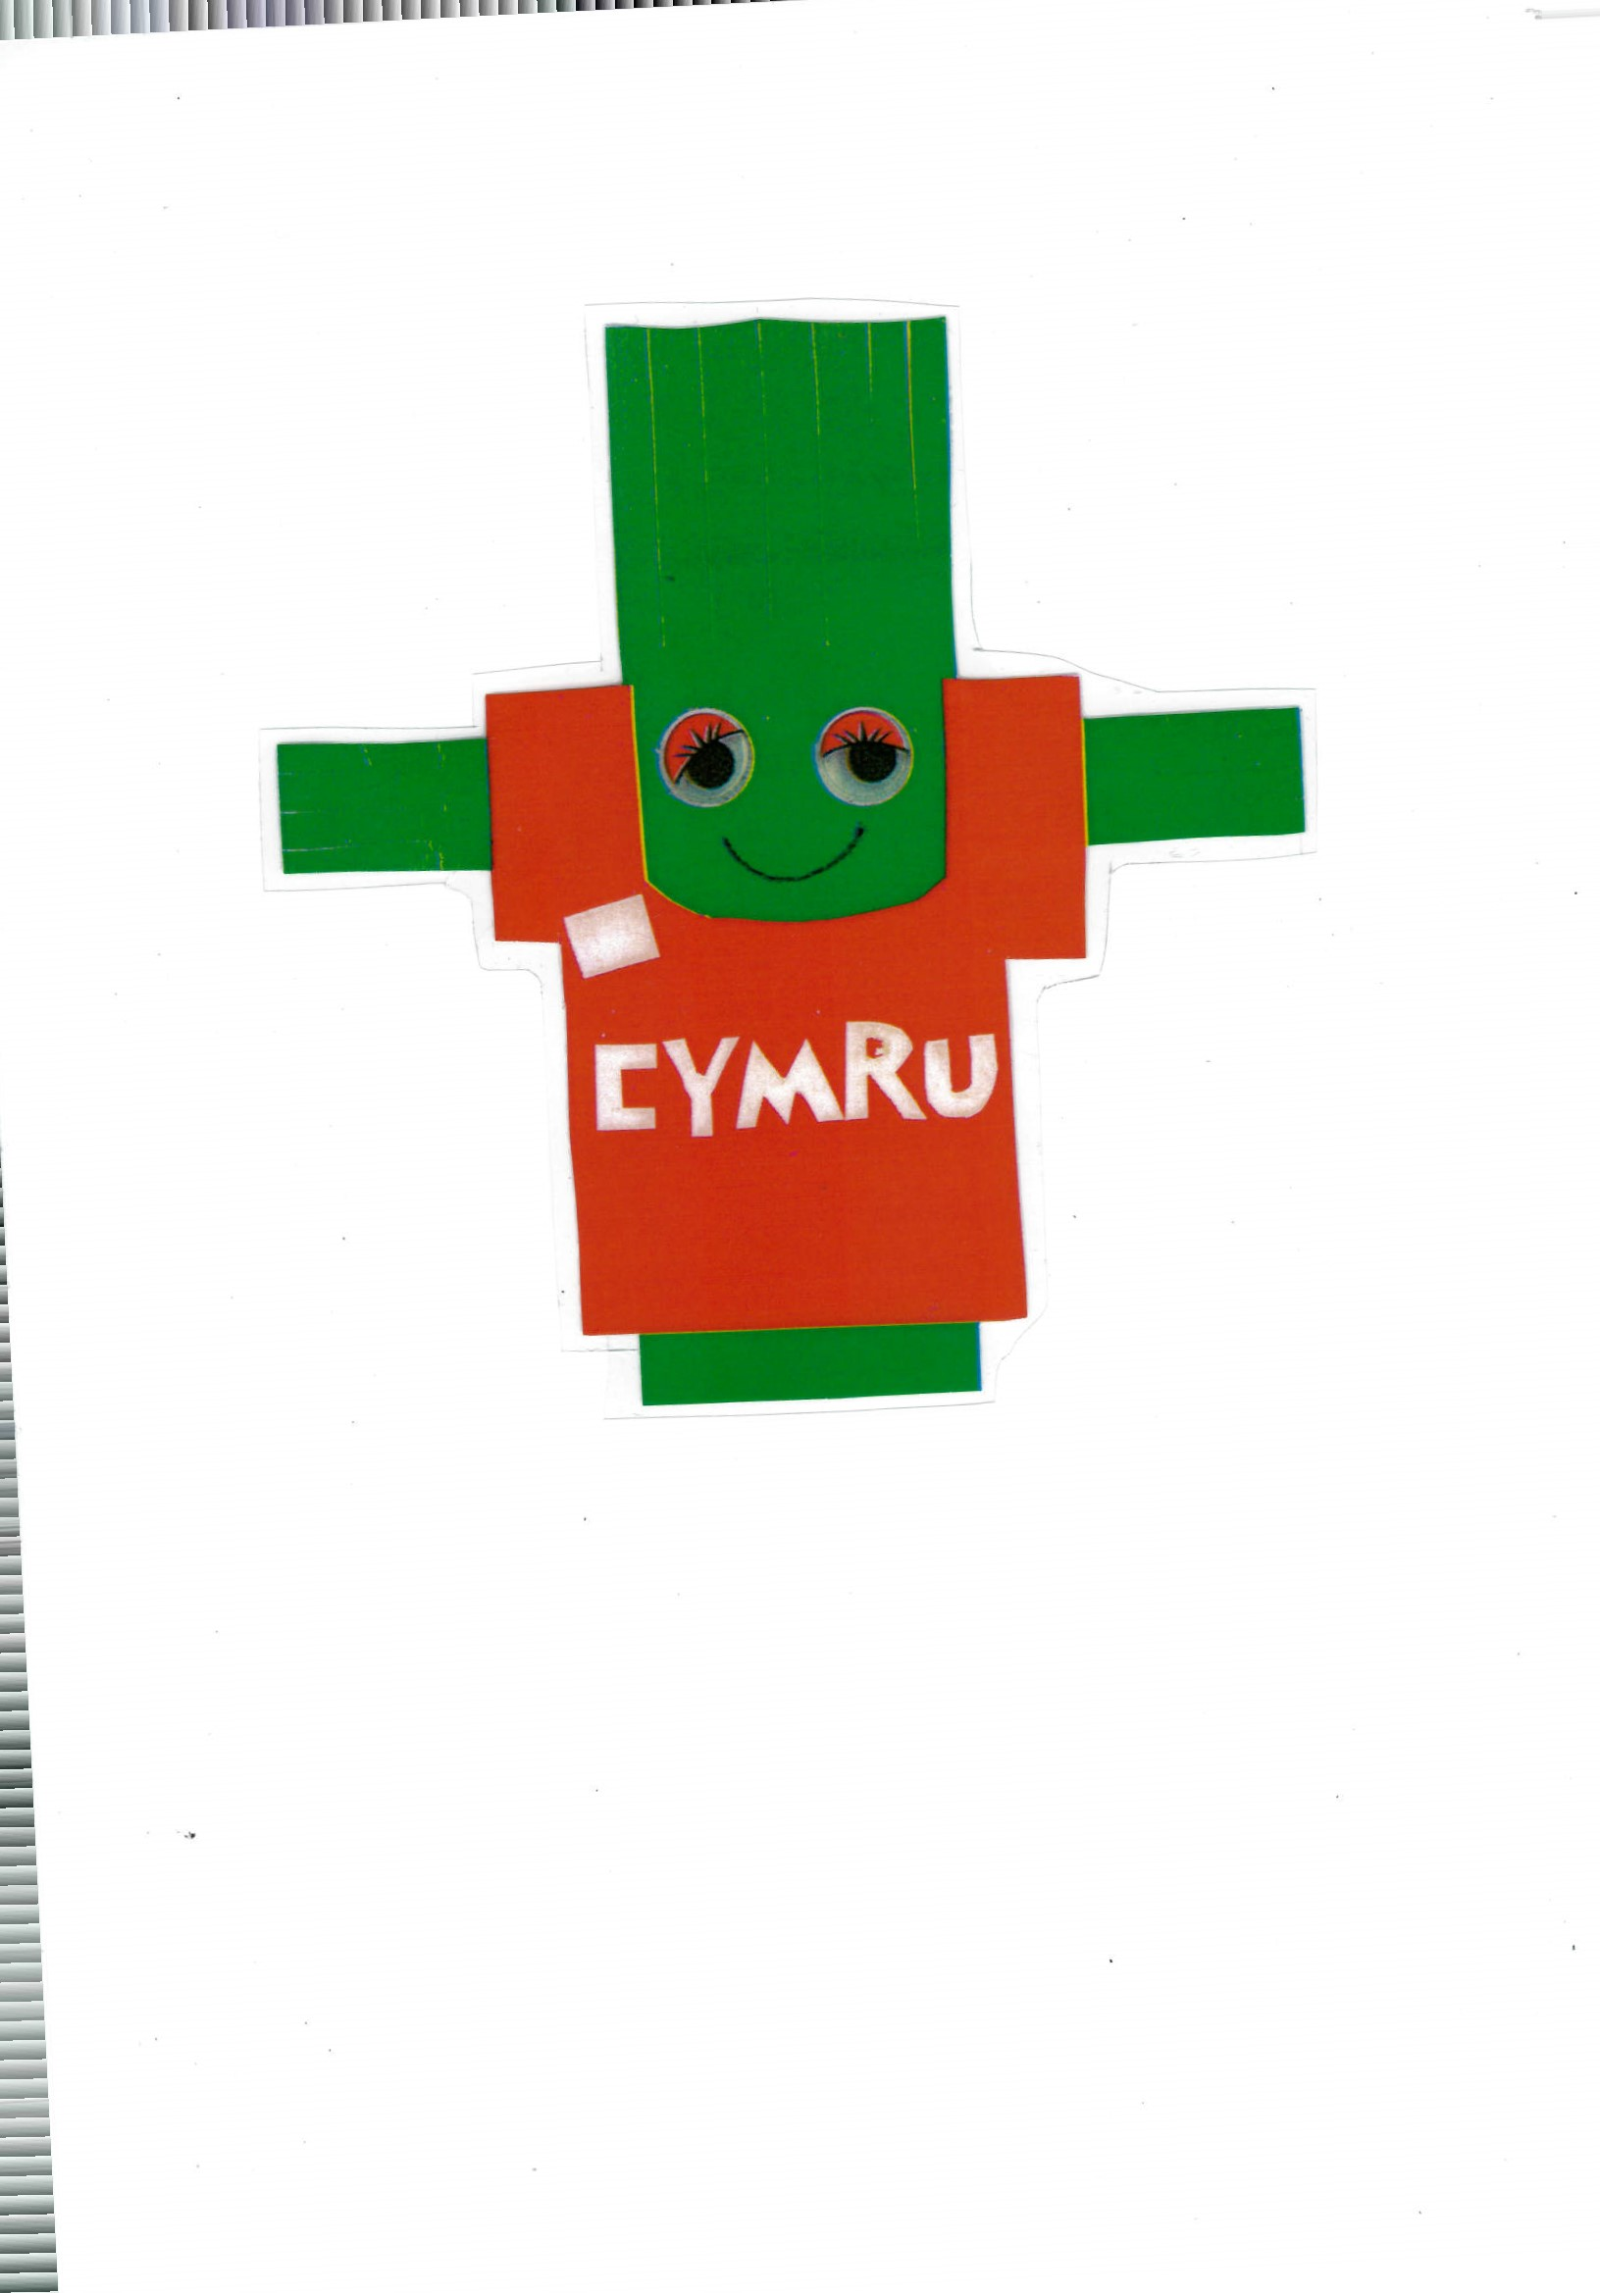
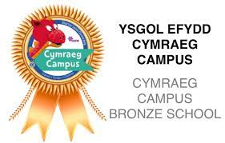Our school has a Welsh mascot. His name is ’Ceri Cennin’ If you see Ceri Cennin around the school you will find welsh writing, work, oracy, culture etc. Dyma’r Ceri Cennin.

We have 2 other mascots who’s names are Seren a Sbarc. They are Welsh superheroes to help us celebrate coming together to speak Welsh.
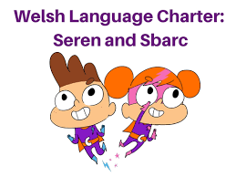

We speak lots of welsh in our school and can earn lots of rewards like Y Ddraig Goch certificates (Welsh speaker of the week), Tocyn iaith, Tocyn Canwr Gwych ( super singer).



Tocyn
Iaith

Canwr
Gwych!

Our job contains the following responsibilities:
- Speaking Welsh around the school.
- Encourage our friends and teachers to speak welsh around the school.
- Think of ways to improve the Welsh in our school.
- Work with Miss Edbrooke and help our school to achieve the 10 targets.
- We try to meet once every half term to talk about how we are doing and if we can think of any more ways to celebrate being Welsh and to help more people to speak Welsh.
- We help Miss Edbrooke to decide what the Phrase of the week is. This sometimes goes over 2 weeks if we are finding it difficult or feel we need more practise.
- We help Miss Edbrooke host the Weekly Welsh Assembly. All songs, prayers, poems and stories will be in Welsh.
- We stand at the front and welcome everyone into the hall and encourage them to sit beautifully, until we are ready to start. Then we need to help giving out certificates and awards. We use a really big word which means congratulations. ‘Llongyfarchiadau!’
- We share the new Phrase of the week and make sure it is displayed around the school.
- We have another big job and that is to make sure the teachers are using and speaking Welsh during the day. We listen at lunchtimes, break times, during assemblies, lessons and when coming in and going home from school. Our teachers and staff are really good at speaking Welsh to us and to each other. They are very competitive and we choose which member of staff has spoken the most Welsh and is invited to our assembly to accept their award of a Criw Cymraeg badge, so they can join our ‘Criw’ for the week and help us on our journey.

Please help and support us at home to keep speaking and learning Welsh. There are lots of apps and websites advertised on our school Website and HWB Classrooms to help.

We need you!

Diolch Pawb

Criw Cymraeg
Katelyn, Harri, Theo, Ioan, Alex, Ollie, Dexter, David, Lexi-Mai, Lexi, Millie, Kristen, Rikki a Miss Edbrooke.

