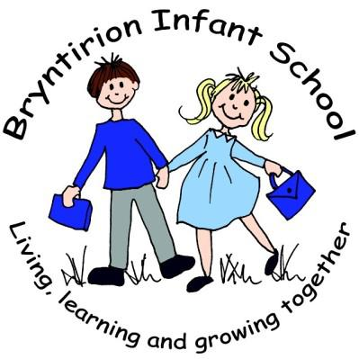

PROSPECTUS
PROSPECTWS

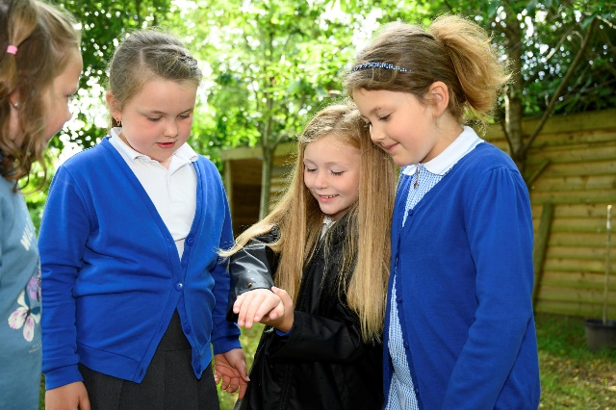
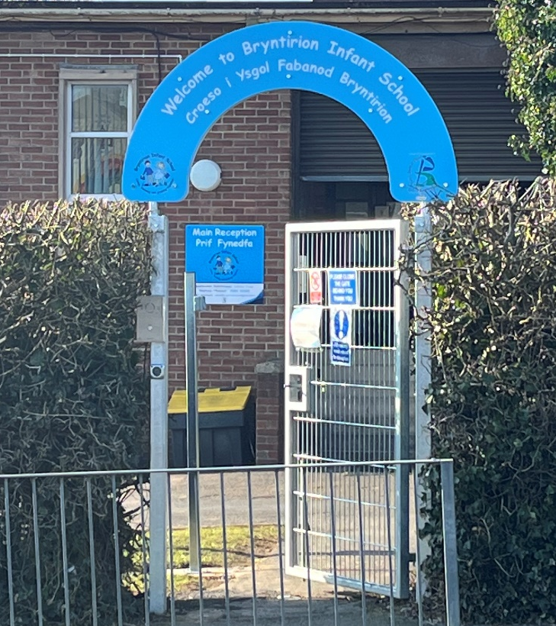
2024-2025

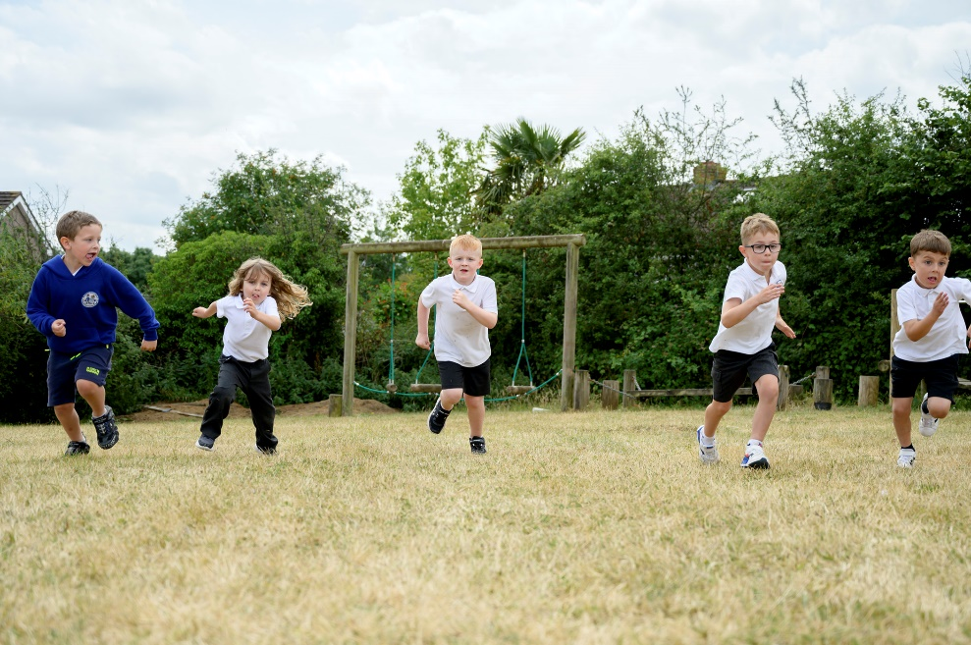

Bryngolau,
Bryntirion,
Bridgend
CF31 4DD

www.bryntirioninfantsschool.co.uk
admin@bryntirionis.bridgend.cymru
Telephone: 01656 815860

he

Welcome to Bryntirion Infant School
Croeso i’r Ysgol Fabanod Bryntirion

Bryntirion Infant School was built in 1955 and has been expanded as the community has grown. We are one of only two infant schools within the borough of Bridgend and are experts in early childhood education. We are a happy and friendly school that offers children between the ages of 3-7 years an exciting range of authentic learning experiences. I hope this prospectus helps you gain an insight to life at our wonderful school.

I am delighted to be the Headteacher at Bryntirion Infant school and it gives me great pleasure to provide you with an overview of our school…welcome! Selecting a school for your child is often one of the most difficult decisions a parent has to make. We want you to make the right decision for your child. Please feel free to contact us if you have any additional questions not covered in this prospectus or would like a visit.
Our school is a special place for children and their families to feel part of a learning community and we are excited for the future. Our official opening was 19.6.56 and have provided high-quality education for over 60 years. We are an inclusive, community focussed school within the Bridgend Local Authority and serve the communities of Bryntirion and surrounding areas. However, we also have pupils attend from outside of the catchment, everyone is welcome! We have a mixture of mainstream and specialist observation classes. Our children learn in six class bases, and we currently have 131 pupils on roll. We believe that for a child to thrive, we want them to feel safe and happy whilst working within an atmosphere of trust and respect. Pupils will engage in learning that provides authentic learning experiences where their knowledge and skills will be purposeful. We have high expectations and standards for all learners. Our curriculum involves all learners and pupil voice is key. We are aiming for children who have a love of learning and are empowered with knowledge and skills that will support them in an ever-changing world so they may take their place in society as caring, independent, responsible and reliable citizens. Our Curriculum for Wales curriculum will enable our learners to be…
- Ambitious, capable learners
- Ethical, informed citizens
- Healthy, confident individuals
- Enterprising, creative contributors
We hope that while reading our prospectus you feel the sense of achievement, enjoyment, excitement, hard work, love and care that the children at our school experience during their time here. We very much want to continue a partnership between home and school as it is through working together fostering mutual respect and support that we can provide what is best for our children to ensure our pupils receive the best possible start in life.
Yours sincerely / Yr eiddoch yn gywir,
Mrs. Katrina Pryse
Headteacher / Prifathrawes

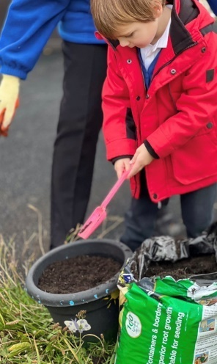
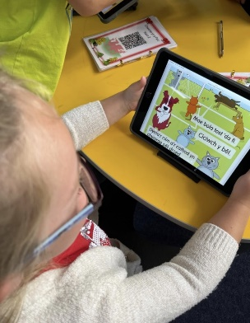
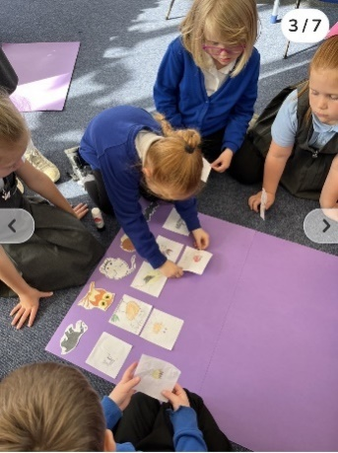

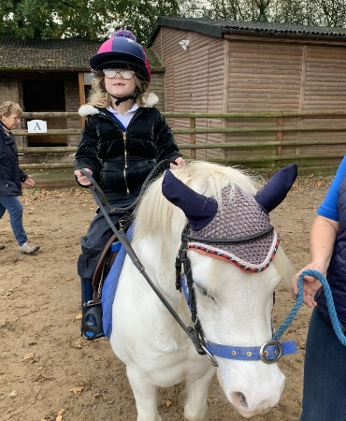

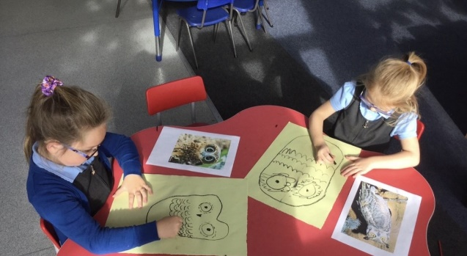

Our School
Our Motto:

This motto reflects our understanding and beliefs, as we aim to ensure, we are a community where all children feel loved, respected and encouraged to develop to their full potential.

Our Vision:
We feel it important that every child, have RIGHTS to…
Reach for the stars: so they dare to dream that a bright future is achievable as staff have high expectations for every child & themselves. Where the children persevere and succeed in life.
Inspired: believe in themselves and have high levels of self-esteem and well-being and know what to do to achieve their dreams.
Gain knowledge and skills: which will make them literate, numerate and technologically prepared for the future and know these are being closely monitored so success is achieved.
Highest quality teaching and learning: which fosters independence, collaboration, inquisitiveness, innovation and curiosity; with staff who want to make a difference and care about their future, no matter that their starting point is.
Transferability: where skills and knowledge learnt in school can transfer into real life jobs in the future.
Safe: where pupils feel safeguarded, nurtured and cared for.

Our Mission:
To empower and skill staff in creating aspirational teaching and learning opportunities which result in children who are happy, thrive, have personal drive, take risks, have a sense of heritage, perseverance, and know that creativity is just as valid as academic success.
We have fostered a caring school community which supports the development of the whole child, where well-being is considered just as important as educational attainment and achievement.

Living, learning and growing together!
Byw, dysgu a thyfu gyda’n gilydd!

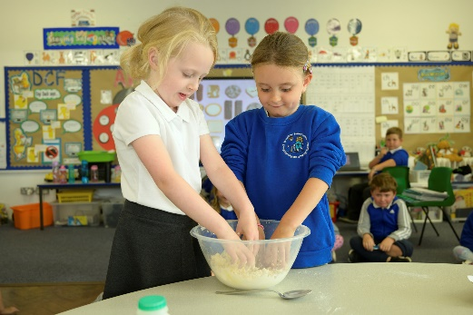
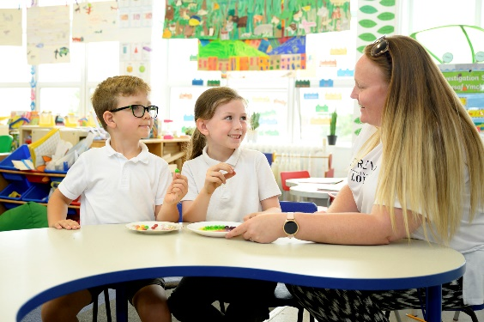
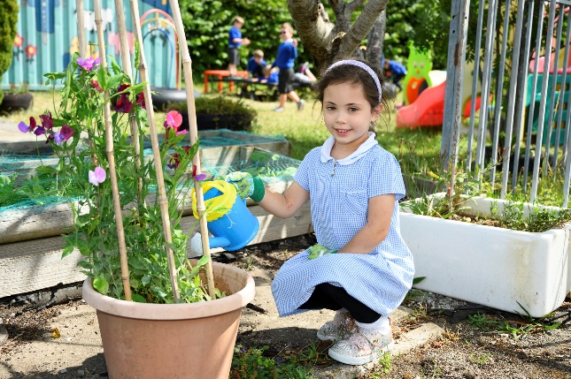

General Information
Admissions:
Bryntirion Infant school is a school for children aged from 3-7 years. The entry of children to schools is controlled by Bridgend County Borough Council. All parents are able to express a preference for the school of their choice when selecting a placement for their child. Parents need to apply for places for children moving from part-time to full-time Nursery, for children going into Reception and for children moving to Year 3. There are deadlines for applications. Once the school is oversubscribed priority will be given to:
• Pupils living in the traditional catchment area.
• Children with siblings attending the school.
All admission paperwork is completed online. Go to… https://www.bridgend.gov.uk/residents/schools-and-education/school-admissions/apply-for-admission-to-school/. For more information email: pupilservices@bridgend.gov.uk or Telephone: 01656 643643

Term times: For the academic year 2024-2025
The school will be closed for INSET training for 6 days over the academic year. We will inform you of the dates in a timely fashion so you can make alternative arrangements for childcare, if needed.

Term | Term begins | Mid-term holiday |  | Term Ends
Autumn | Monday 2.9.24 | Monday 28.10.24 | Friday 1.11.24 | Friday 20.12.24
Spring | Monday 6.1.25 | Monday 24.2.25 | Friday 28.2.25 | Friday 11.4.25
Summer | Monday 28.4.25 | Monday 26.5.25 | Friday 30.5.25 | Monday 21.7.25
We are allocated six INSET Days. So far, we have set… Monday 2.9.24, Friday 25.10.2432 and Monday 21.7.25, there are a further 3 dates yet to be set.

The School Day:
Minimum weekly teaching times DfEE Circular 7/90 sets out the following suggested minimum weekly teaching times as a guide for schools is 21 hours for pupils aged 5-7 years. While the above guidance does not outline the standard minimum hours to be operated by schools, it stands as non-statutory guidance and has advisory status only.

Our school starts at 9.00am and ends at 3:15pm.

Our session times…
9.00am to 10.15am; 10:15am-10:30am, 10.45am to 12.00noon;
1.00pm to 3.15pm. Please note that the school is only legally
responsible for pupils from 9.00am.
Please help your child to establish good habits
of punctuality as any child arriving after 9.10am
will be noted in the register as late and entry
into school is through the main reception area,
where office staff will take your child to their class.

Uniform:
Our school colours are blue, white and grey.
Uniform with a logo can be purchased from
Euroschools or Uniform To Go (both based in
Bridgend). However, you can purchase school
uniform for stores and have the logo added,
if you’d prefer.

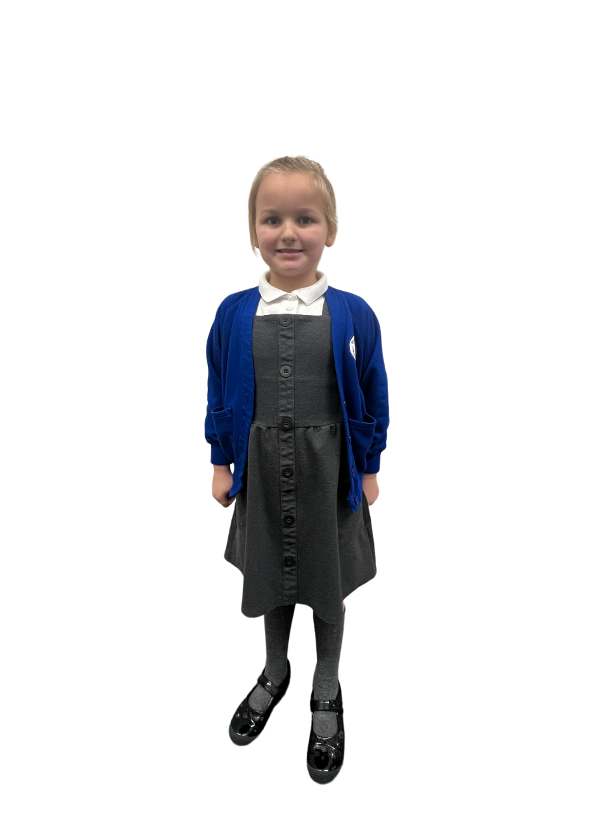




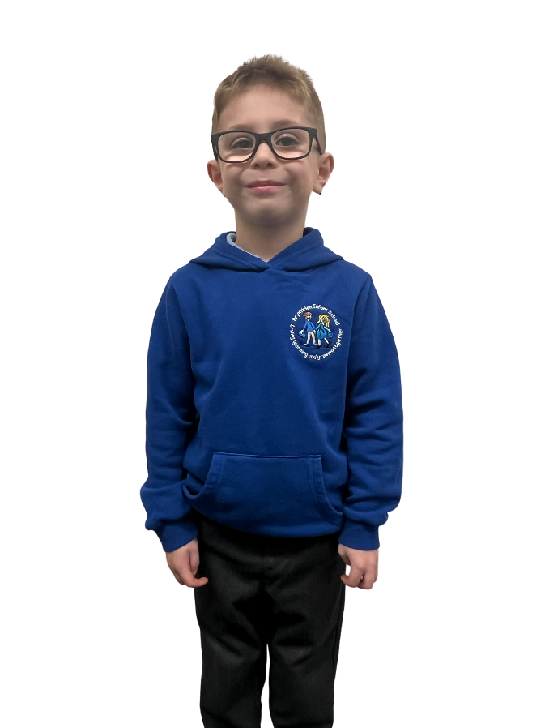

Communication:
We have a comprehensive school website where all information is regularly uploaded and accessible. Additionally, we use other electronic platforms, which are restricted to parents/guardians of pupils who attend the school such as Primary Site as a text service and Facebook for information. Class staff also communicate frequently with families via the SeeSaw app. There is also monthly Headteacher’s newsletters to keep you updated and occasional paper letters sent home with your child. Most of our communication are electronic. #savetheplanet

Meetings with Parents:
We have an open-door policy and are here to support families to ensure children thrive. We formally meet with parents once a year (Autumn term). However, we offer book looks in the Spring term and a parental consultation, if requested in the Summer term. Whilst we prefer face-to-face meetings, we appreciate the complex lives we all live and are happy to meet virtually, using the Microsoft Teams platform. We also issue an end of year report in the Summer term. Parents are further invited to school for… concerts, charity fundraisers, sports events, family engagement activities and additional meetings for children with additional learning needs.
Breakfast Club:
Welsh Government fund this service so Breakfast Club is free for all full-time children and is run by our catering service who also supervise the children until school starts. Children in the club are taken to their classes at the start of the school day. You need to request a place for your child before they can access this service. Breakfast club opens at 8:10am and closes at 8:30am. Entry to the club is via the main yard side door into the school. Children are offered a range of healthy breakfast choices whilst they chat and play with other children from our school. If your child has specific dietary requirements or allergies, please inform staff before they join the club. Parents are requested to complete relevant paperwork before starting at breakfast club- see office staff for this.
Transport:
Some children are provided transport to and from school as they attend from out of catchment areas. Transport is fully funded by Bridgend County Borough Council for children who attend specialist class basses within our school. A responsible adult will travel with your child and the driver. Any questions from parents should be directed to the ALNCo (G. Edbrooke) or Headteacher (K. Pryse).
Charging and Remissions:
The school’s Governing Body has resolved to adopt the Local Authority’s policy on charging and remissions for school activities. Each time an educational visit or event is arranged, parents will be advised of the pro rata cost and invited to make a contribution to that value. If a large number of parents decide not to make the necessary contribution, then the school may decide not to go ahead with the visit or event. Please note that your child’s safety is always the paramount consideration when participating in school activities both on and off site. Also please note that parents may be required to pay for any damage for which their child is responsible, e.g. replacement of books/equipment, etc.
Transition:
Opportunities for your child to visit their Junior Year 3 class occur throughout the year for children who will attend Llangewydd Junior school. However, for those parents who chose another school, we will support any planned transitional arrangements.

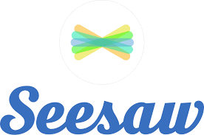


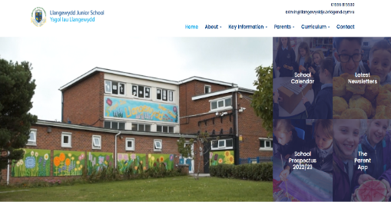

Eating and Drinking:
Food and Growing…We are taking the importance of food very seriously and a big part of our health and well-being curriculum is to ensure that the children learn about health choices and nutrition. Cooking and understanding food is therefore a big part of daily life. If your child has any allergies, please ensure school staff are made aware of these.
School Lunches… Please contact the school if your child has any special dietary requirements or allergies. School meals are available for all full-time children. There is no cost for school meals as Welsh Government provide funding through a scheme called Universal Free-School Meals (Ufsm).
Packed Lunches… Some children prefer to bring a packed lunch. Please ensure that this
contains a balanced nutritional diet as we support Welsh Governments’ “Appetite for
Life” agenda.
Break time… A free daily drink of milk is provided by the Welsh Government for children
up to 7 years of age. Water is available for the children throughout the school day. We
welcome parents sending in reusable water bottles, that are labelled with your child’s name.
Pupils also receive fruit daily. A contribution of £4.00 every half term is asked for this provision. Money is given to the class teacher weekly or half termly. If you wish your child to have something to eat during morning break from home, we ask you to send a healthy snack – fruit or vegetables.
We are proud to have achieved our Eco-Platinum flag and Healthy School awards which demonstrate our commitment to improve the lives of our little ones.

Awards:
Awards, even from a very young age, teach our children that their efforts have been
recognised and appreciated. Our Seren Yr Wythnos (Star of the Week) award are
nominated by the class staff for effort with work, values or behaviour. These are
awarded during our Friday Celebration assembly by the Headteacher.
The Headteacher’s Super Hero Award is available any day of the week. A child may
be brought to the Headteacher as they have shown that they have met one of our
four core purposes such as…. an incredible piece of work (a creative contributor) or
for being kind to a peer (ethical citizen) or for making good snack choices (healthy
individual). These are nominated by any member of Bryntirion staff.
Staff also use a range of stickers, stampers and WOW prizes to reward children.

GDPR:
All data will be treated in accordance with the General Data Protection Regulation 2018 and you can read our data privacy notice on our website or contact the school office.

Policies and Procedures:
Here at Bryntirion Infant School we work hard to maintain good relationships with parents and the community.
These are based on mutual respect and a willingness to listen. If you need further information about
how we do things, a copy of our policies and procedures can be found on the school website.

Free-school meals (eFSM):
Your child may eligible for funding for uniform, extra money for schools under a scheme called Free-School Meals (eFSM), please speak to our administrative staff who can provide you with more information.
Your child may be able to get free school meals if you get any of the following:
- Income Support
- income-based Jobseeker’s Allowance
- income-related Employment and Support Allowance
- support under Part VI of the Immigration and Asylum Act 1999
- Child Tax Credit (as long as you don't also get Working Tax Credit and your annual income is £16,190 or less before tax)
- the guaranteed element of Pension Credit
- Working Tax Credit run-on - paid for 4 weeks after you stop qualifying for Working Tax Credit
- Universal Credit - your household earnings must be less than £7,400 a year after tax. This does not include any income from benefits.
The application form can be obtained from https://www.bridgend.gov.uk/residents/schools-and-education/grants-for-pupils/free-school-meals-fsm/

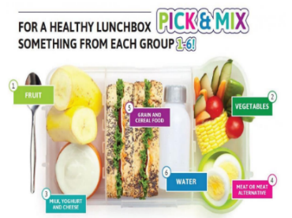

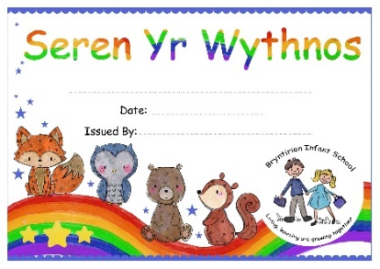

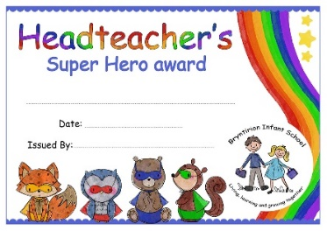

SOur Team
Senior Leadership Team:
Katrina Pryse (Headteacher) Lisa Hearn (Acting Headteacher) Gill Edbrooke Acting Deputy Head, (ALNCo)

Teaching Team:
Class base | Teaching Staff
Dosbarth Cyw  Nursery | Chloe Morgan Cover Supervisor  Rachel Roberts LSO  Louise Bullock LSO
Dosbarth Aderyn Du  Reception / Year 1 class 1 | Ellie Rees Teacher  Francesca Evans LSO
Dosbarth Aderyn Can  Reception / Year 1 class 2 | Aimee Crumbie Teacher  Courtney Dearman LSO
Dosbarth Hwyaden  Year 1/2 | Rachel Williams / Merrial Tunnadine -Teachers  Louise Bullock LSO  Louise Anderson (ancillary LSO)  Rebecca Hill (ancillary LSO)
Dosbarth Palod  Reception, Year 1and Year 1 SP | Lisa Ryan Teacher  Emma Stevens SSO  Rachel Llewellyn SSO  Rebecca James (ancillary LSO)  Taylor Hayden (supply LSO)  Tamsyn Roberts (supply LSO
Dosbarth Robin  Nursery, Reception, Year One and Two SP | Gill Edbrooke Teacher  Beth Theophilus SSO  Beverley Borge LSO  Sandra Harris (ancillary LSO)  Claire Chapman (supply LSO)  Georgina Meaton (supply LSO
Non-teaching Team:
Name | Role
Juliet Owen | Senior Administrative Officer
Joanne Davies | Clerical Officer
Lyndon Borge | Site Manager
Kayleigh Bassinger | Cook
Tanya Clear, Veronica Vass | Lunchtime staff
Wendy Bryne, Tracey Lewis, Rebecca Hill, Summer Wilson  (all LSOs and SSOs also cover lunchtime) | Lunchtime Supervisors
Liane Nota, Agneta | Breakfast Club Supervisors





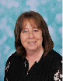
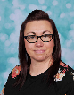
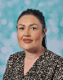

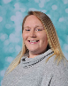

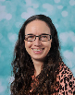
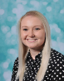


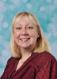
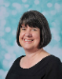


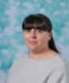
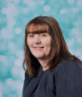
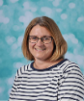

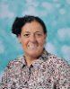
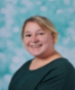
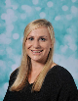

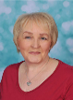

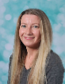

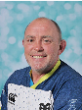

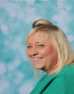
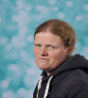
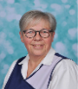
Governors
Welcome message from our Governing Body:
Dear Parent/ Guardian,
Croeso i ysgol Babanod Bryntirion.
I have great pleasure, as Chairman of a very active and committed governing body, in inviting you to join our school community by enrolling your child/ children? Enclosed is detailed information regarding our school please read through it and any further information required do not hesitate in contacting us, you will be most welcome to do so. Bryntirion Infants has and is an important part of the community especially regarding the Education and Development of our children guided by Welsh Government legislation and the local authority.
Here in Bryntirion we have a committed staff and a great team spirit working together to enthuse our pupils to enjoy life through a good and stable grounding to their Educational needs. Our P.T.A is part of our team giving invaluable assistance and support and are always looking for new members.
Diolch am gymryd amser i ystyried ein hysgol a gobeithio y byddwch yn ymuno a ni yn fuan.
Yours sincerely,
Jeff Lewis
Chair of Governors
The governing body at Bryntirion Infant school has responsibility for the strategic management of the school, acting within the framework set by national legislation and by policies of the Local Authority. The internal management of the school is the responsibility of the Headteacher. The Governing Body meets at least once a term and, in addition, subcommittees meet regularly to review the various areas of the life and work of the school. They report to the full Governing Body for formal ratification of proposals. The minutes of Governing Body meetings are available from the Headteacher, on request. Governors are required by law to publish an Annual Report to Parents which is distributed to all parents in the summer term. The current membership of the Governing Body is outlined below:
Governor Name | Governor Type | Area/s of responsibility | End of service
Jeff Lewis | Chair of Governors (LEA) | Language Literacy and Communication AoLE, Expressive Arts AoLE | 14.9.27
Mark Davies | Vice Chair of Governors  Local Authority Governor (C) | Science and Technology AoLE, Mathematics and Numeracy AoLE, ALN Governor | 14.9.27
Lisa Jackson | Parent Governor (P) | Expressive Arts AoLE | 8.3.26
Joanne Thomas | Parent Governor (P) | Humanities AoLE  Health and Wellbeing AoLE | 8.3.26
Carly Theyer | Parent Governor (P) | Science and Technology AoLE | 12.12.25
Charlene Powell | Parent Governor (P) | Language Literacy and Communication AoLE,
Cllr Sarah Philpin | Community Governor (C) | Mathematics and Numeracy AoLE | 5.5.26
Eric Pearson | Local Authority Governor (LEA) | Humanities AoLE
Sue Lewis | Community Governor (C) | Health and Wellbeing AoLE
Katrina Pryse/Lisa Hearn | Headteacher (S) | All | Not applicable
Lyndon Borge | Support Staff Governor (S) | Health and Wellbeing AoLE | 4.12.26
Lisa Ryan | Teacher Governor (S) | ALN Governor

The clerk to the Governing Body is Simone Delaney and can be contacted via School Governance Solutions Ltd., 8 Acland Road, Bridgend. CF31 1TF. If there are any issues you would like to raise with the Governors or you would like to join our Governing body Team, Ms. Delaney can be contacted.



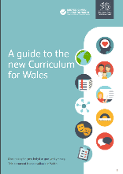
Curriculum for Wales (CfW)
At Bryntirion Infant school, children are given the opportunity to become:
- Ambitious, capable learners, ready to learn throughout their lives and achieve to their full potential. Bryntirion pupils will be able to seek to challenge themselves and others, question the world around and lead their learning.
- Enterprising, creative contributors, ready to play a full part in life and work, drawing on their resourcefulness. BIS pupils will actively engage in real life experiences to allow them to solve problems that are purposeful.
- Ethical, informed citizens, ready to be citizens of Wales and its world with a secure understanding of their culture and heritage. BIS pupils will be respectful and honest in their every day lives, making good choices about their behaviour and finding out about values and beliefs in communities.
- Healthy, confident individuals, ready to lead fulfilling lives as valued members of society with a knowledge of mental and physical wellbeing. BIS pupils will have a sense of belonging and will build positive relationships through experiences built on happiness and laughter.
The children explore these four purposes with the help of the Bryntirion Buddies who provide the connection for the children.

Our curriculum has been shaped by Welsh Governments CfW agenda which includes:
- 6 Areas of Learning and Experience from 3 to 16 years or age;
- 3 Cross curriculum responsibilities: literacy, numeracy and digital competence;
- Progression reference points at ages 5, 8, 11, 14 and 16;
- Achievement outcomes which describe expected achievements at each progression reference point.
The curriculum is organised into 6 Areas of Learning and Experience:
- Expressive arts;
- Health and well-being;
- Humanities (including RE);
- Languages, literacy and communication (including Welsh);
- Mathematics and numeracy;
- Science and technology.
Around our school you will see 6 colours of a rainbow.
Each colour links to one of the Areas of Learning and
Experience (see above). This is a great way to get the
children to connect to their learning.

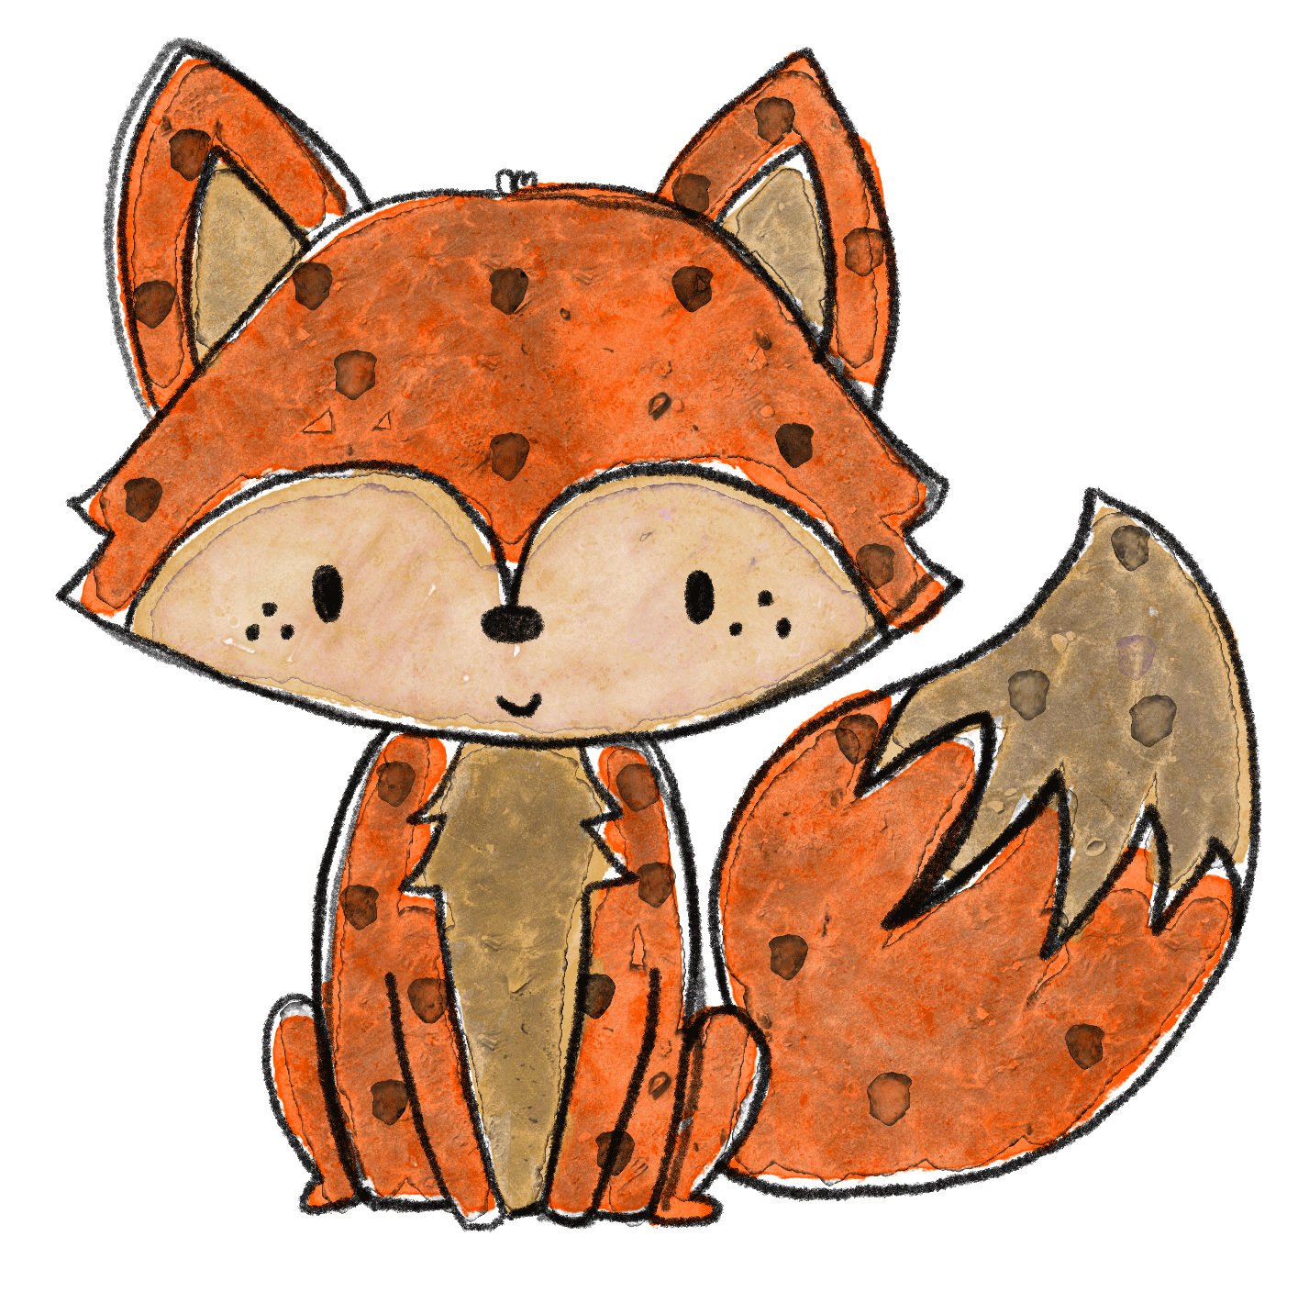
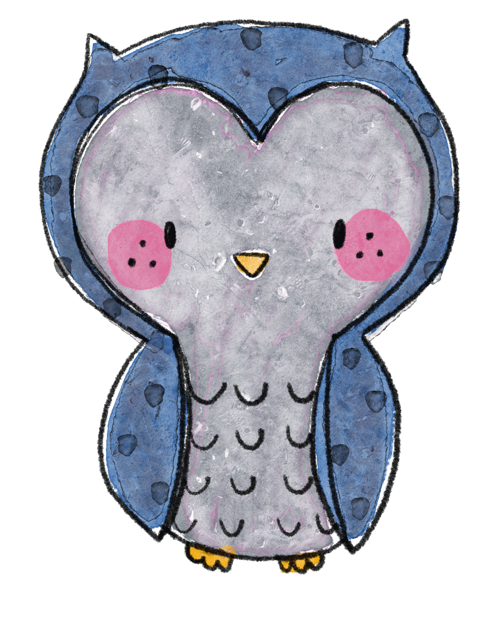
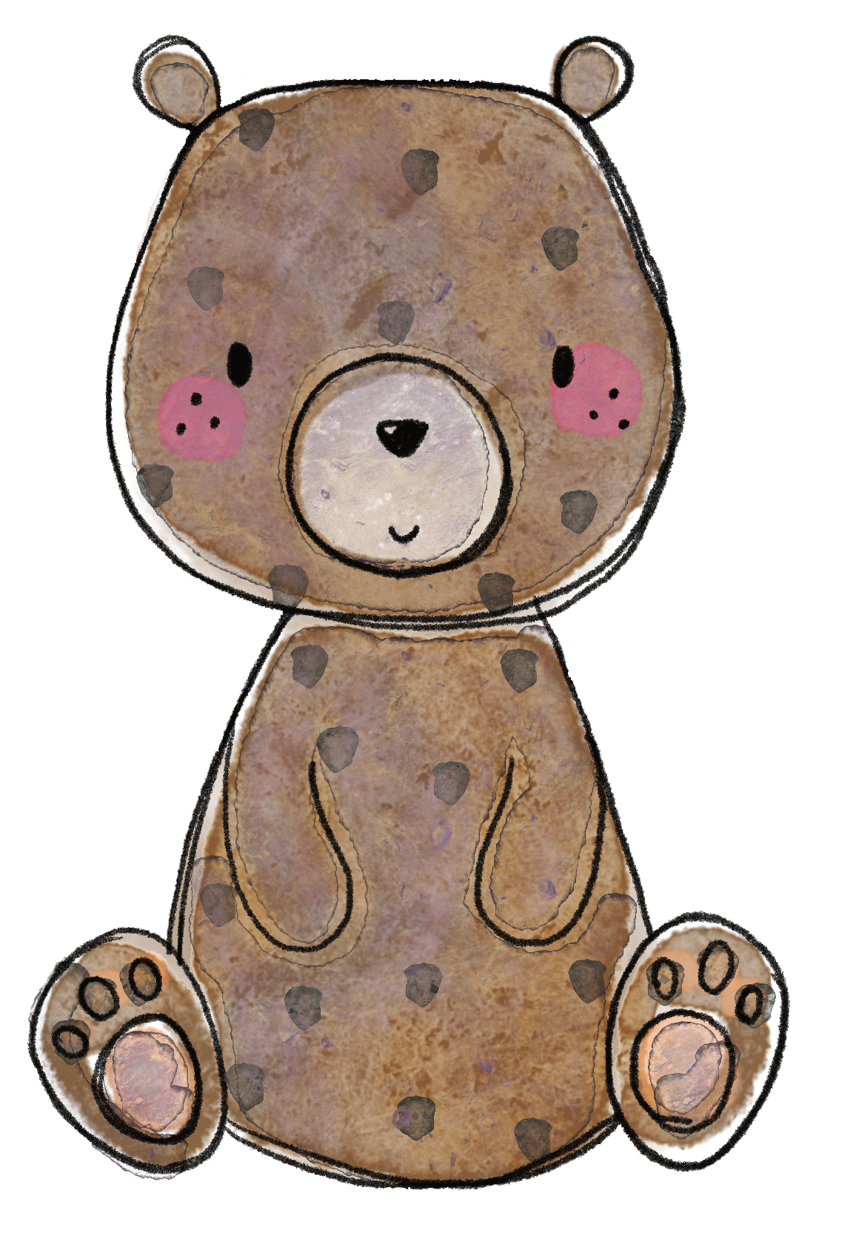
This is…Hetty
1
4

This is…Eddie

This is…
Ethel
This is…Arthur
2
3

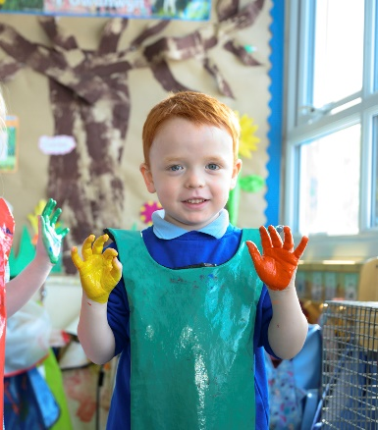

Learning through play:
Effective practice places great emphasis on the holistic development of children and the development of skills across the curriculum building on previous learning experiences and knowledge. By providing a broad, rich and exciting curriculum both indoors and outdoors, using a variety of approaches, we develop children as individuals, recognising their level their personal motivators and interests. Children of all ages learn through play and this is a crucial time for developing lifelong learning skills by being curious and exploring. They learn how to observe, listen, respond and develop as individuals and learn how to work individually and as a team. Your child may come home with resources they have used in school on their clothes e.g. mud. Celebrate that they have been actively involved in their learning.
Bilingualism:
English is the main language of communication, teaching, learning and assessment at Bryntirion Infant School. However, the school is committed to promoting the aims and aspirations of the Welsh Government in developing Bilingualism. In our school both English and Welsh will be functional languages. We will promote oracy, reading and writing in both English and Welsh Second Language in informal and structured situations. Welsh will be seen and heard around the school, during school assemblies and concerts, signage and displays, lessons and indoor and outdoor activities. We are passionate about being Welsh and have shown our commitment by our involvement with Welsh Governments’ ‘ Siarter Iaith’, for the development of the Welsh language which we have achieved our bronze award.
Religion, Values and Ethics (RVE) and Relationships and Sexuality Education (RSE):
At Bryntirion we believe all children need to know their rights and know the power of having a voice. We create a safe and inspiring place to learn, where children are respected, their talents are nurtured and they are able to thrive whatever their circumstances or starting points. We have achieved Our Rights Respecting Schools Bronze Award which shows that these values are embedded in daily school-life. We also believe the ethos of the school should be built on a foundation of core values. These will be embedded on a monthly basis throughout the curriculum and will also be addressed in assemblies and Collective Worship. Our values are the basis for the social, intellectual, emotional, spiritual and moral development of the whole child. We encourage the children to consider these values, thereby developing knowledge, skills and attitudes that enable them to develop as reflective learners. Our VIEWs (Values, Independence, Ethics and Wellbeing) help to give children the best chance to lead happy, healthy lives and to be responsible, active citizens.
View | Month | View | Month
Friendship | September 2024 | Confidence | March 2025
Respectfulness | October 2024 | Tolerance | April 2025
Kindness | November 2024 | Resilience | May 2025
Responsibility | December 2024 | Honesty | June 2025
Caring | January 2025 | Happiness | July 2025
Ambition | February 2025

Daily collective worship in school is conducted through group whole school assemblies, class reflections and a weekly whole school celebration assembly. Within these learning sessions topical issues and big questions are explored and feedback is collected and shared and ties into our VIEWs. RVE and RSE is mandatory in the Curriculum for Wales, for all learners 3 – 16 years of age, as a part of the Humanities Area of Learning and Experience.

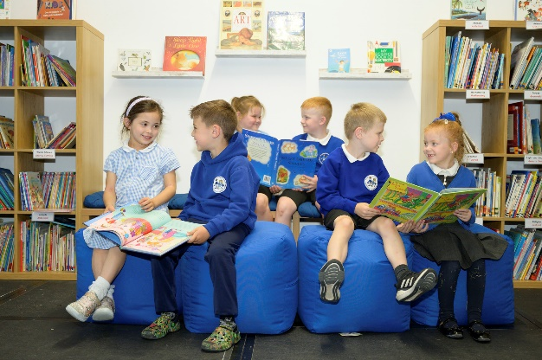
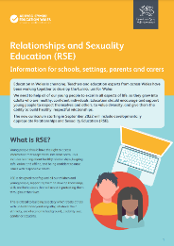
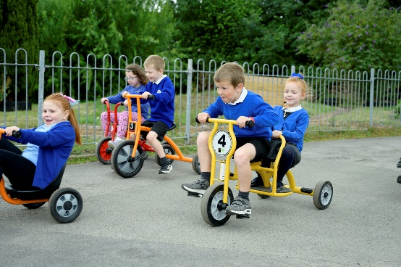

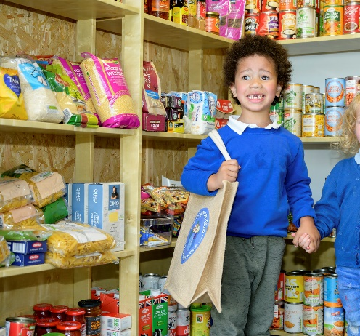

Additional Learning Needs (ALN)
At Bryntirion Infant School we are proud of the support that we offer for our learners with Additional Learning Needs. We feel that all learners within the school are supported well, and that we have positive working relationships with learners and their families, as well as other individuals and organisations that work with the young person. We feel that the support, guidance and interventions that we offer is tailored to meet the needs of each learner individually, and that this support is monitored and adapted in a pupil-centred way.
Additional Learning Needs legislation in Wales is changing, and this is known as The Additional Learning Needs and Education Tribunal (Wales) Act 2018. The Additional Learning Needs and Education Tribunal (Wales) Bill was passed by the National Assembly of Wales on 12th December 2017 and became and Act on 24th January 2018 after receiving Royal Assent. At Bryntirion, we are working hard to prepare for these changes as there is a roll out plan set by Welsh Government. However, in September 2021 the Additional Learning Needs and Educational Tribunal (Wales) Act came into force and as a school we are working on ensuring that this will be a smooth transition from the old SEN system to the new.
The law is changing for several reasons:
- The child or young person’s needs might be found too late;
- The support might be provided to the young person too late;
- The young person and their parents/carers might not be involved enough in planning;
- The current system can be complicated to understand;
- The law only currently covers children and young people up to the age of 19.
The new legislation for ALN will bring about several main changes for ALN. It:
- Brings together all current systems into a new, single system for ALN;
- Changes terminology- Special Education Needs (SEN) has been replaced by Additional Learning Needs (ALN);
- Is pupil centred, where young people and their parents are completely involved in decision making;
- Provides learners with the same type of statutory plan (Individual Development Plan or IDP), irrespective of age or setting;
- Improves transition between settings;
- Allows further Welsh language provision;
- Has clear and consistent right of appeal;
- Is a fair and transparent system for all.
For more detailed information about the ALN reform, please click the following link:
https://www.loom.com/share/c720fa47ec4347d3b08627a2e4a5dccb alternatively, to find out more see the Welsh Government video link below: https://mail.google.com/mail/u/0/?tab=rm#inbox/FMfcgzGkXmhvdDpMgRRLNmMffjKMZfTp?projector=1
Supporting information is available for parents and learners. In this section of the website, you will find links to help sheets and further information about how the changes will affect learners and their families, and what support is available to you. You will find it useful to read the booklet ‘BIS ALN Handbook’. However, if you still require any further information about the changes or are concerned your child has an additional learning need then we welcome you to contact us. You can contact us at the school and ask to speak to the Additional Learning Needs Coordinator (ALNCo), Gill Edbrooke or Katrina Pryse, Headteacher.

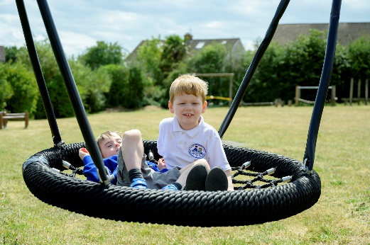
ALNCo
Gill Edbrooke




Safeguarding and Child Protection
Here at Bryntirion Infant School we take the well-being of all our children very seriously. We have a comprehensive Safeguarding and Child Protection Policy. All staff and volunteers at the school who come into contact with the children have a DBS check and all staff and governors receive training relating to safeguarding and issues. These are placed as high priority within the school. The school’s safeguarding officers are Katrina Pryse (Headteacher) and Lisa Hearn (Acting Headteacher). The deputy safeguarding officer is Gill Edbrooke. The Governor responsible for safeguarding is Jeff Lewis. If you have a concern about the welfare of a pupil, we urge you to speak to us.
Alternatively, you can contact the Local Authority Multi-Agency Safeguarding Hub (MASH) if you have a concern which occurs outside of school. Your call can be anonymous! The duty desk information is…

Information, Advice and Assistance (IAA) Team (for children)
Phone: 01656 642320
Email: mashcentra@bridgend.gov.uk
Health and Safety
Routine check-ups: Throughout their time at Bryntirion Infant School, children will undergo various health check-ups by the school nurse such as sight, weight, hearing and teeth etc.. You will be informed if any problems are detected requiring your child to be referred for further treatment.
Head lice: From time to time, there are outbreaks of head lice within every school. Regular checks are the only way to stop the lice spreading and we do appreciate the support of parents in this matter.
Injuries: In cases of a serious injury, parents/guardians will need to be contacted. It is essential that more than one emergency contact name and telephone number be provided on the enrolment form. If your child becomes ill or has an accident during the school day, appropriate first aid or other care will be administered and you will be notified as soon as is practicable. However, when there has been a head injury, parents will always be contacted. A first aid slip will also come home.
The Administration of Medicine: If it is necessary for your child to receive medication during the school day then a medication consent form must be completed. No medication will be administered unless this form has been authorised by the headteacher. Only medicines that have been prescribed four times a day will be administered in school. Parents are welcome to visit the school and administer medicines if needed. Only prescribed medicines, in the original container, issued by a pharmacy, can be administered. Medication kept in school such as asthma pumps or Epipen’s MUST be labelled with your child’s name and will be kept by the class teachers.
Absences: If your child is unable to attend school please inform us by telephone (01656 815860) by 9:30am on the morning of an absence. If your child becomes ill during school time- we must have up to date contact numbers so that we can contact you. Punctuality and attendance are very important and we will contact you if either are a concern. If your child is late for school, they must enter via the main entrance and report to the school office so that they can be marked on the register and their lunch preference logged. Our school’s attendance target is 92%.
Clothing: Please ensure your child is wearing appropriate clothing for the weather. School has a limited supply of clothing for outdoor learning, parents are requested to send in appropriate kit e.g. wellies.
School Access: Help us to provide a clean, safe environment by following these few simple rules: Please park
away from outside the school gates on the zig-zag lines. Please do not smoke anywhere inside the school buildings,
grounds or on school trips. Dogs are not permitted inside the school grounds.
Smoking: From 1st March 2021, all school grounds in Wales are required to be smoke-free. It is an offence
to smoke on school grounds. The legislation that sets out the details are section 10 of the 2017 Act and
regulations 10 and 12 of the 2020 Regulations. A fine for non- compliance can be endorsed.





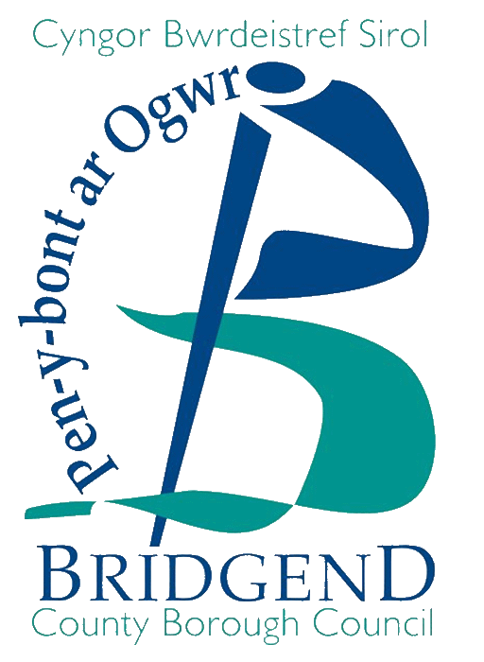

Version 1
Thank you for taking the time to read all about our school and we look forward to you becoming part of our Bryntirion school family!

